Case study
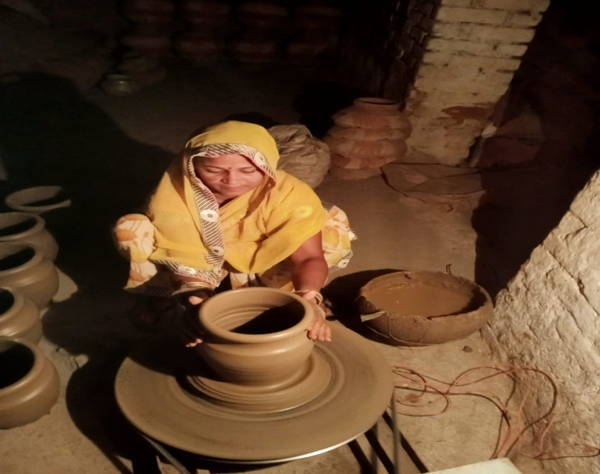
Ms Suman Prajapat is operating Suchna Kendra in Chattarpur from last 4 years. Making terracotta products is her main occupation. She always try to resolve the issues of terracotta workers. They all use to make terracotaa products by hand but once she seen on female was making terracotta products with wheel machine. She informed to organization and then organizer and she gathered information about that machine and came to know that IN HAND WORK INDIA CO provide this type of training. She prepared 18-community list and provided training. All community brought machine and making terracotta products and form the earning fulfilling their basic amenities.

