Case study-1
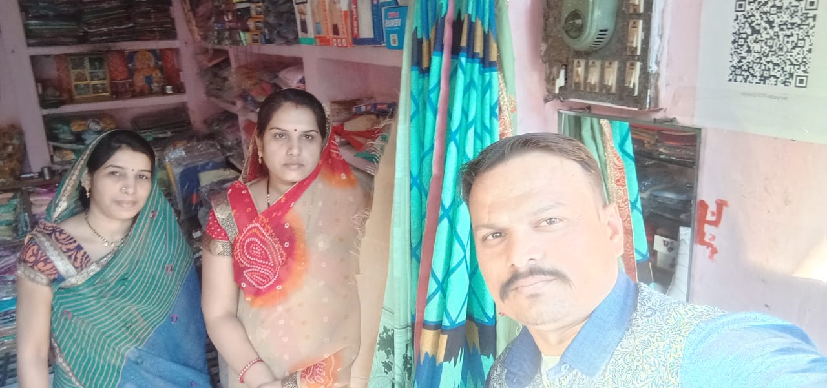
I am Ravina Yadav. Resides in Ozar vilage of Barwani District. My village has about 5000 population. Before couple of years ago, I had started my own cloth shop for getting livelihood. Earlier I use to cash payment only at shop but from March 2020 due to lock down banks were closed by government and ATMs did not have aquacade amount. It these situation customers weren’t buying cloth from my shop. I was varied about business and then one day in April Month Ms Sangeeta Malviya visited by shop and informed me about the Digital mode of Payment and how it can be helpful for my business.
She helped me for putting barcode at my shop and properly oriented me for the same. Now costumers are buying cloth from my shop and paying through digital mode.
I am very thankful to her she has helped me and now again customers have increased at my shop and I am able to run my business properly without barrier of cash payment.

Women Entrepreneurs Case study -2
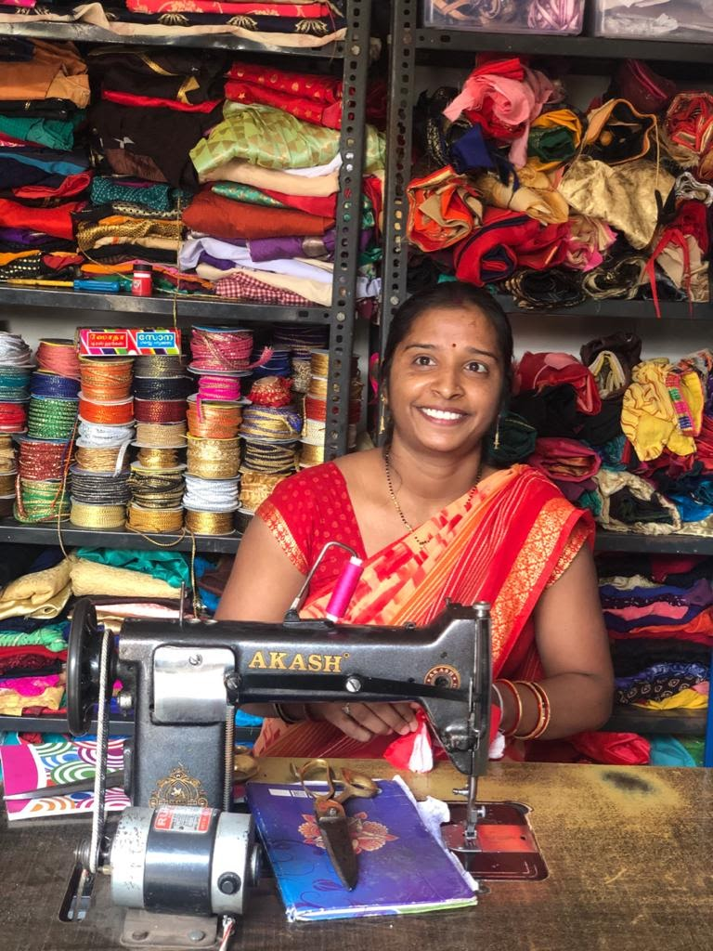
I am Rekha and I am 28 years old. I reside in Ozar village of Barwani district. When I was in 10th class I got married. There are 6th members in my family and only my husband is earning member in family. He earns 4000 per month from agriculture related work. That amount was not enough for our family. I was unable to pay me children fee and other expenses of the family.
I always felt that my low education level insufficient to work and earn some money for my family. I knew stitching since past few years but I was not perfect tailor. So I was unable to earn money from tailoring. I used to stitch clothes at home, but do not get enough customers.
Last year organizer came to my house and informed me that they are conducting up skill training for tailoring work and I also can be part of that training. organizer motive me that after training I will be able to earn more money. Then I participated in training programs which were provided by the organization.
After getting training my stitching has a smooth finishing, after I learnt cutting and tailoring. Now I have become a perfect tailor community appreciate my work and recommend other to get their cloth stitched from me.
I have opened my own boutique shop in market and organizer are providing me help for getting orders and through which I earn 15000 per month. From this income, I support my family's expenses and now we are able to fulfill all basic amenities of my life and also can pay children fee.

Women Entrepreneurs Case study -3
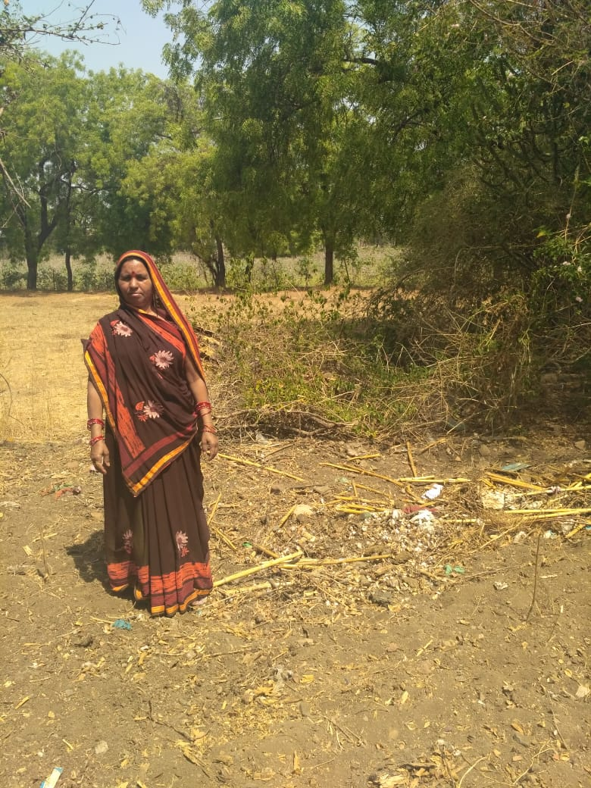
My name is Kusum Yadav. I am 42 years old and reside in Barwani district’s Anzad village. My husband’s name is Bhihari Yadav. There are 8 members in my family. I do agriculture work with my husband and we both are the earning members in our family. Our family’s main source of income is Agriculture. But we do not have proper irrigation felicities due to this problem we face challenge for fulfilling basic amenities of the house. Earning from agriculture was not enough for our family.
In this situation we were looking on the sky for any help than organizer came on my house and she informed me that they are going to conduct training program with women’s group for enhancing the skill and knowledge about business. That will be helpful for increasing income and expanding our business.
After one month organizer filled my form and I got orientation on entrepreneurship Development, leadership and up-skilling. Where I learned that how I can increase my income and how agri inputs can be reduced.
After getting training I started vermi composting and pesticide with help of locally available natural inputs. organizer provided help to me for getting tarpaulin sheet for composting pit and then I prepared Vermi compost and reduce agri input cost up to 10,000 Rs. I also prepared pesticide at home and saved 4500 Rs.
As I learned sowing processes, input practices and other things in training programs we followed same during wheat sowing and got good result. Our yield has increased 3 to 4 quantal per Biga.
Total I received benefit of 35000 Rs wheat in this year and now my family is able to fulfill basic amenities with support of training programs. We can buy grocery items every month from that amount and now there is no need to get support from other persons.
Case study -4
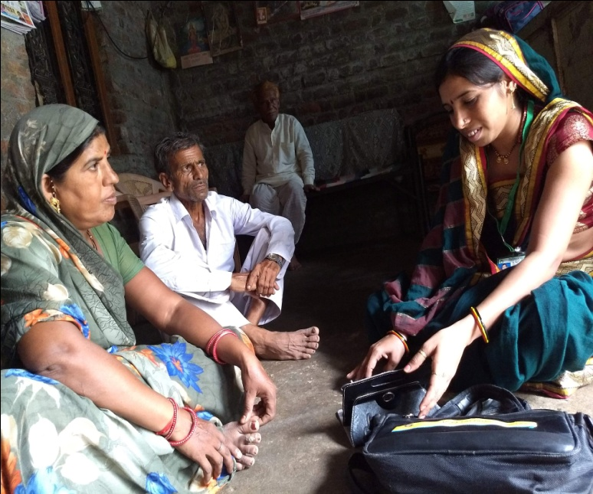
There was a time when neighborhood women and her mother-in-law would chide Nirmala Yadav if she stood at the doorway of the house that was home to her 10 member joint family. Thanks to organization those days are long gone.
Nirmala who didn’t have a bank account, who wouldn’t venture out, today walks the length and breadth of her village teaching people how to make digital transactions. She takes the villagers’ problems to the Panchayat, helps people open bank accounts, apply for government schemes like health, pension, etc. She is passionate about telling women the importance of saving, of opening their own bank accounts and making digital transactions, which save time and effort.
At the home-front, Nirmala taught her husband who is a farmer how to use GooglePay and Bhim. Her father-in-law is very happy that she is involved in service for the society.
Ever since she became a member of our organization, her entire family has been very supportive. Her husband bathes, dresses the children and also makes snacks for them. Her father-in-law who earlier would ask he to make tea does it himself. Her mother-in-law and other members pitch in with her share of household work.
“Earlier my identity was tied to that of my husband. Now it’s the other way round, says Nirmala with a smile. “I’m known as the didi with the bag or mobile.

