Program: Digital Sakhi Program in MP

Organization Name: Mahila Shram Sewa Nyas

Reporting Period: Annual report (01 Apr 2019 –31st March 2020)

Program Location: Barwani and Dhar District of Madhya Pradesh

I. Summary

Key Activities

- Digital Sakhi program proposal and budget were developed for FY-2020-2021 from 1st April 2020 to 31st March 2021.
- 20 New villages were identified nearby old villages across both districts because Digital Sakhis were unable to reach target numbers due to unavailability and unwillingness of villagers.
- To build rapport with key stakeholders and village residents, community meetings were conducted in all project villages across both districts.

- Women Entrepreneurs from all 5 trades were selected and trained.
- Digital Sakhi and Women Entrepreneurs Assessment for the year were done. PPT was prepared by Sattva team and presented to LTFS.
- End Year Assessment of Digital Sakhi and Women Entrepreneurs Assessment survey was done.
- One-day Leadership Development Training was organized for the Women Entrepreneurs at the district level in order to build their confidence and leadership qualities.

- Door to Door visits were conducted by Digital Sakhis for Digital Financial literacy and Government Entitlements.
- Pre- Post training formats were filled for EDP and Upskilling trainings of Women Entrepreneurs.
- Training was given to field team to fill the Impact Assessment questionnaires for Digital Sakhis and Women Entrepreneurs by the team using Social Cops mobile application.
- Digital Sakhi and Women Entrepreneurs Impact Assessment were done by using Social Cops mobile application.
- Digidhan Camps were conducted in both Districts.
- EDP and Upskilling trainings were conducted with 1000 WE in both districts.
- Entitlement training was conducted with Digital Sakhi in 4 batches for train them on 21 Government Entitlement Schemes.
- Participated in LTFS board Member’s meeting.
- 4 batches of advance mode of training were provided to Digital Sakhis.
- Every month Community voice messages were disseminated to 12,000 community members
- Designed and printed booklets on Advance mode of payment and Entitlement Schemes.
- Digital Sakhi weekly meeting were conducted.
- Village level weekly meetings were conducted by field team.
- Focus Group Discussions were conducted with weak WEs.
Program Management

- Bi-monthly visits by the LTFS CSR team and Sattva team.
- Review and planning meetings of Digital Sakhi field teams were held at the MSSN office.
- Monthly Meetings were held at MSSN-Indore office.
- Daily reporting and weekly con call with field team by project coordinator.
- Weekly check-in calls were help between MSSN, LTFS and Sattva.

II Program Overview

Detailed Program Highlights
Proposal Development for the period 1st April 2020 – March 2021

- Digital Sakhi program proposal and budget were developed for FY-2020-2021 from Apr 2020- to Mar. 2021.

- The Budget and proposal was developed and submitted to L&T Financial Services (LTFS) in March 2020.

- LTFS provided suggestions to further strengthen the proposal and budget, which were duly incorporated.

Program Awareness in Project Villages
- Village residents were provided information on the Digital Sakhi program, Digital Financial Literacy and Government Entitlement across the 41 villages in Dhar & Barwani districts.
- Meetings with Gram Panchayat Sarpanch, Gram Panchayat Secretary, village head and village residents were conducted on a regular basis.

- Regular communications were done with DM and other government departments regarding program success and for seeking their support in program.

- In each village, regular community meeting were organized and informed about project and digital mode of payment and entitlement schemes. 960 meetings were conducted at village level by project staff and information was shared with 24961 community members.

Mobilization of WE

- Mobilization of Women Entrepreneurs is being done in five identified trades – agriculture, stitching, goatery, dairy, poultry and petty shopkeepers.
- WEs were mobilized and gathered for EDP, Upskill and Leadership trainings.

Participation in Board Member Meeting Program in Chennai:
- Project Director, Project Coordinator and one Digital Sakhi participated in the program.
- Presented yearly success of the project in front of LTFS board members.
- Digital Sakhi Ms Meena Maru also shared her experience in program.

Digital Sakhi Entitlement Training:

- The training was conducted by MSSN MP in 4 batches across 2 districts of Dhar and Barwani.
- Trainings were provided by subject experts. Participants were trained on 21 government entitlement schemes.
- A total of 97 (out of 99) Digital Sakhis participated in the training.
- 2 Digital Sakhis were absent owing to health-related reasons.

Digital Sakhi Advance mode of payment Training

- 100 Digital Sakhis were trained on Usage of BHIM, USSD, Dos and don’t of digital payments
Changes observed in the Digital Sakhis:
- Shift in behaviour as Digital Sakhis regularly use various digital payment applications.
- Digital Sakhis are able to communicate benefits of digital financial literacy to the wider community.
- Digital Sakhis are well aware of how to make secure payments and avoid frauds.
- Through their efforts, 8545 community members have reported using digital payments.

Digital Sakhi Door-to-Door Training:

- During reporting year 106912 community members were visited by the DS.
- Community members were made aware about the21 government social security schemes which were related to Insurance, livelihood, pension, subsidy, etc.
- As result total 19432 forms were processed and 11232 Community members were benefited from Entitlement Schemes.

Design of knowledge dissemination booklets for advanced modes of payment and government entitlements:

- 105 booklets were designed and printed on advanced modes of payment and Government Entitlement Schemes.
- The design for these booklets was provided by LTFS for advance mode of payment. The content in the booklets was translated from Marathi to Hindi by the MSSN MP team and the booklets were subsequently printed and provided to all Digital Sakhis.
- The content and booklets were Designed by MSSN MP for Entitlement
- Booklets for Advance mode of payment and 21 government entitlements schemes were designed, printed and distributed to Digital Sakhis of both Districts.
- Booklets were used for bringing awareness amongst 1, 00,000 community members on Digital Payments and Entitlements by the Digital Sakhis.

Leadership trainings:

- Leadership Trainings21 batches were conducted for Women entrepreneurs against targeted 30 in Dhar and Barwani Districts.
- A total of 724 WEs was trained during the reporting year against the planed 1000 WE, across both districts.
- The trainings were conducted to develop the leadership qualities and facilitated by Mr Ram Bende from Pune(MH)

The training focused on:
- Self-awareness
- Self-confidence and self-motivation
- Leadership skills & mindsets
- Public speaking

Entrepreneur Development Program (EDP) Training for Women Entrepreneurs:

- During reporting period 31 EDP batches were conducted against planned 30 batches.
- Total 1013 WEs participated in training against planned 1000 WE.
- Trainings were provided to Agriculture, dairy, Goatry, Poultry and Stitching.
- They were oriented on Entrepreneurship, saving, loaning, etc.
- After training as result all WEs have started saving.

Up-skilling training for Women Entrepreneurs:

- During the year a total of 32 up-skilling batches were conducted against planned 30 batches.
- Out of 1036 WE, a total of 1002 WE participated in the training.
- Each batch was for 5 days and provided by Central for Entrepreneurship Development of Madhya Pradesh (CEDMAP).

Digi-Dhan Camps

  - A total of 91 camps were conducted, across both districts against planned 100 camps.
  - Total 20291 community members were participated in camps against targeted 25000 community members.
  - Community members were made aware about Jan-Dhan account, Digital Payments and Entitlement Schemes.
  - After camps community is able to make Digital Payments and process government entitlement forms.

Community Voice Messages:
- Every month voice and text messages were disseminated to 12000 community members on Digital Payment and Government Entitlement Schemes.
- Content was developed by MSSN MP and shared with LTFS & Sattva for approval.

Focus Group Discussions with weak WEs

Discussion points of FGD
- For providing information to weak WEs on their business, FGD were conducted with 202 Wes.
- They were informed about their business, opportunities, bottlenecks, etc.
- Future planning was discussed.
- How they can get support for business from government departments.
- Where they require handholding from MSSN team.
- How they can be linked with Market for getting good price

Monitoring & Evaluation

- Digital Sakhi and WE End year assessment was done by the team using the Social Cops mobile app.
- Pre and Post Training Assessment forms of Women Entrepreneurs were filled and data was provided to Sattva Consulting.
- Quarterly meetings (for 4 quarters) were conducted during the project period. These meetings were conducted with the Digital Sakhi Staff Team at MSSN-Indore Office. The quarterly reports were presented district-wise and quarterly planning was prepared.
- Bi-monthly meetings were done with the Digital Sakhi at district office respectively.

- Monthly meetings were organized at MSSN – Indore office with team. These meetings were used to discuss the monthly report and create district plans for the following month together with the field teams.

- Weekly conference calls were conducted to provide updates to Sattva and LTFS.

III. Output

Output
Over 1, 02,223 community members have been reached to share knowledge on Advanced Modes of Payments. Through these efforts:
- 10292 members have installed digital payment applications.
- 8545 members are frequently making online Digital Payments.
- 7685 members are using AEPS, since they do not have smartphones.
- 3725 Members opened bank accounts and linked their accounts with their mobile numbers.
- 6524 members started using ATMs through the efforts of the Digital Sakhis.

1, 06,912 members were reached to share knowledge of government schemes. Through these efforts:
- 19432 community members applied for schemes during this time, through efforts of the Digital Sakhis.
- 11230 members got benefits of entitlement schemes, as reported to the Digital Sakhis.

Impact
Changes
- Economic empowerment as shared by the Digital Sakhis:

  - Majority of the Digital Sakhis are contributing to household expenses.
  - Majority of Digital Sakhis have also started regularly saving a part of their income.
  - There is increased involvement of Digital Sakhis in household decision making.
  - Digital Sakhis are also contributing to their children’s education expenses.
  - DS Kavita Maru is pursuing BSW with help of her own salary.
  - DS Anita Patel provided Rs. 20,000 to her husband to purchase agricultural equipment.
  - DS Sunita Ben provided Rs. 30,000 contribution to her house renovation expenses.

  - Aarti Chouhan, Digital Sakhi from Dasai shared that due to having loss in agriculture her husband was unable to pay EMIs. She paid her husband’s EMIs for the month of August.
  - Another Digital Sakhi Sumitra shared that previously her husband paid for their LPG cylinder but in August they booked their LPG cylinder online through her account.
  - Priya, another Digital Sakhi, has started paying her son’s school fees every month.

- Changes in Women Entrepreneurs:

- WE Rani Mansuri has opened her own tailoring shop. She shared that after the training, she got the confidence to start her own shop and now her income has increase from Rs. 1000 to Rs. 3500 per month.
- WE Kesar Ben in Village Labriya has started providing training to other women in her village. As result, her earning has increased and now she is saving Rs. 1000 per month in the bank.
- WE Rekha has started selling clothes in her house, apart from tailoring.
- WE Deepika has started saving Rs. 50 per day and has also started making digital payments.
- WE reported that after the training their saving habits have improved and they have started to keep record of their daily income and expenses.
- They are also keen on taking loans to expand their businesses and WE Manju Buhan reported having applied for Pradhan Mantri Mudra Yojana.
- One of the WE reported expanding her business and starting a new product line.
- Women Entrepreneurs have also started making digital payments.

- Change in Community members:
- There is an increase in adoption of Digital Modes of Payments.
- Community members are now proactively approaching Digital Sakhis to get information on digital modes of payment and government entitlements.
- One Digital Sakhi reported that when she went to one of the houses initially some of the members were hesitant to be part of the session but when they observed their family members taking the session from the Digital Sakhis, they also joined in.
- Community members have started proactively reaching out to Digital Sakhis to receive various information.
- Women in the community, with the support of the Digital Sakhis, have reported going to the banks themselves and not relying on other household members for the same.
- Community is availing government Schemes with the help of Digital Sakhis.

- Increase in engagement of Digital Sakhis with community and WEs:

- Regular meetings were conducted between Digital Sakhis and Women Entrepreneurs, across villages.
- There has been increased engagement of Digital Sakhis with Panchayat, Health Department, WDC department to increase access to entitlements for community members.
- Through efforts made by Digital Sakhis, 52 UPI barcodes were displayed at shops in Dhar and Barwani Districts.
- Saving accounts Surksha Bima, Jeevan Jyoti Bima were accessed by community members and aadhar cards were made with the support of Digital Sakhis.
- Regular meetings are being conducted between Digital Sakhis and women entrepreneurs, across respective villages.
- There has been increased engagement of Digital Sakhis with Panchayat, Health Department, WDC department to avail entitlements for community members.
- Digital Sakhis of Dhar and Barwani Districts participated in 8 Village Assemblies wherein they supported the creation of the respective annual budgets.
- Through efforts made by Digital Sakhis, UPI barcodes were displayed at shops in Dhar and Barwani Districts. ▪
- Saving accounts were opened for community members, Ayushman Bharat cards were provided to community members and aadhar cards were made with the support of Digital Sakhis.

IV.Benefits to community members

SN | Name of the Scheme | Total
1 | Digital Payment App download(Bhim,Phone Pay,Google Pay) | 911
2 | Online Payment Started | 842
3 | Bar Code displyed in Shops | 787
4 | Adhar Card | 596
5 | Surakha Bima | 1653
6 | PM Jivan Jyoti Bima | 1585
7 | Saving Account | 1223
8 | Atal pension Scheme | 430
9 | ARM Card | 831
10 | Ayushman Bharat Card | 4868
11 | Ujjwala Gas scheme | 800
12 | Old age Pendion | 448
13 | widow Pension | 543
14 | Viklang Pension | 77
15 | Lalali Laxmi Yojana | 376
16 | Nishakt Yojana | 0
17 | Janani suraksha yojna | 75
18 | Birth Certificate | 11
19 | Sukana samrdhi yojna | 518
20 | Pradhan mantri mudra loan | 4
21 | Loan from L&T financial Services | 65
22 | Prdhanmantri Crop Insurance | 246
23 | Cattle Insurance | 253
24 | Avas Yojna | 278
25 | Toilet Construction | 569
26 | Job provided under National Rural Employment Scheme | 649
27 | Benefits from building and other construction welfare board of MP | 55
28 | Benefits from Food Security Act | 137
29 | MP Shramyogi Maan-Dhan Scheme | 119
30 | Benefits from Matratva Vandana Scheme | 171
31 | Benefits from KIsan Samman Nidhi | 759
32 | Aadaar base unable system | 691
33 | Mobile numbers linked from Bank account | 773
34 | Usages of Debit card for purchasing | 100
35 | MP Jan-Dhan Scheme account opening | 116
36 | Death Assistance | 4
37 | Made Identity cards | 25
38 | Benefits from SAMBAL Scheme | 31
39 | Benefits from other schemes | 160
 | Total | 21779
Images of activities conducted in the reporting year

Digital Sakhi Door to Door Visit
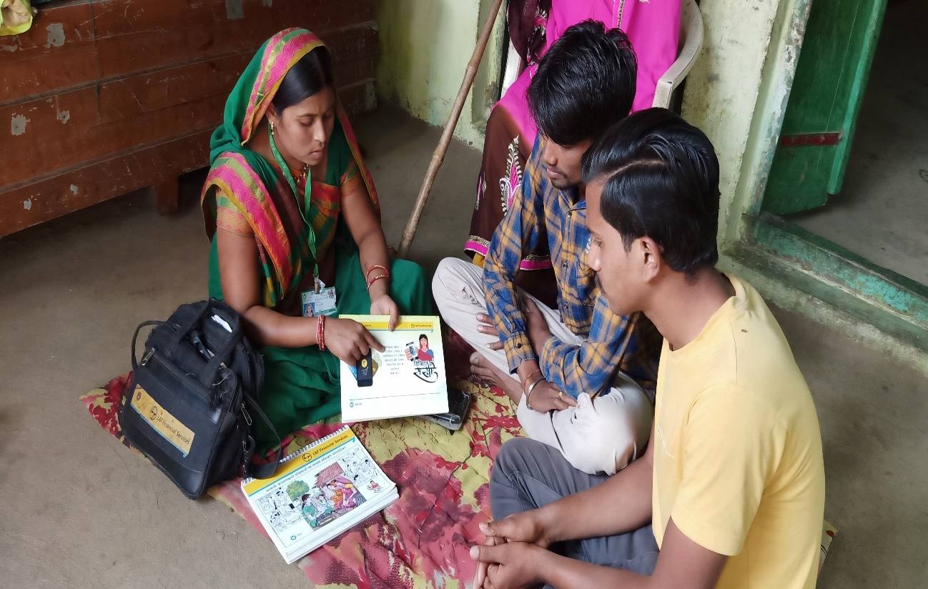

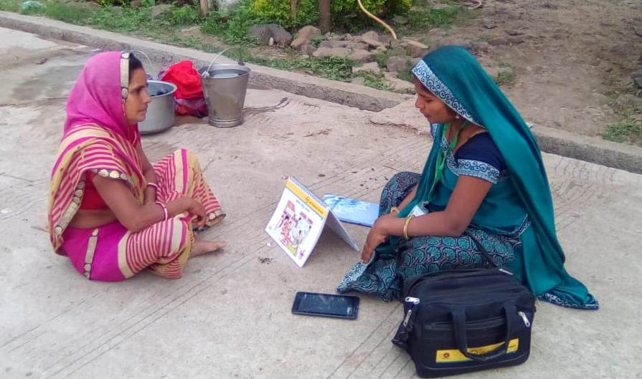

Training on advance mode of payment training Dhar & Barwani

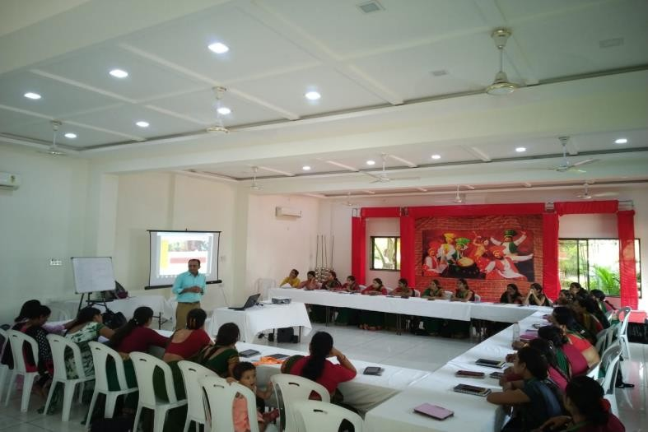

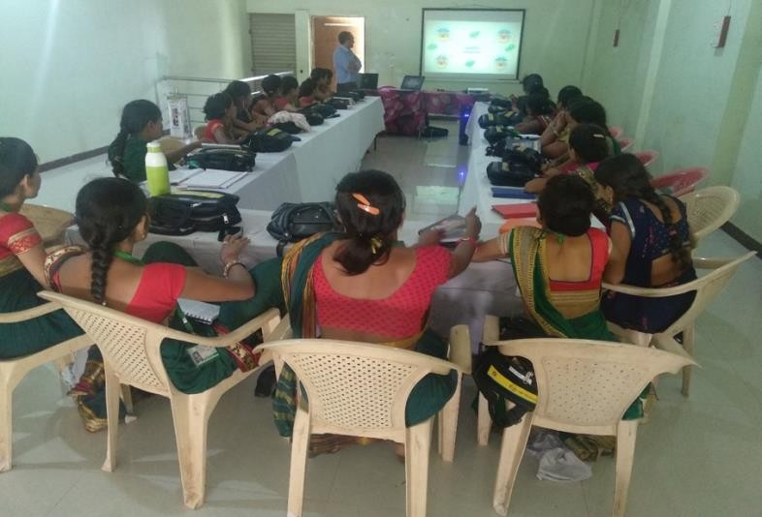

Leadership Training in Dhar and Barwani.
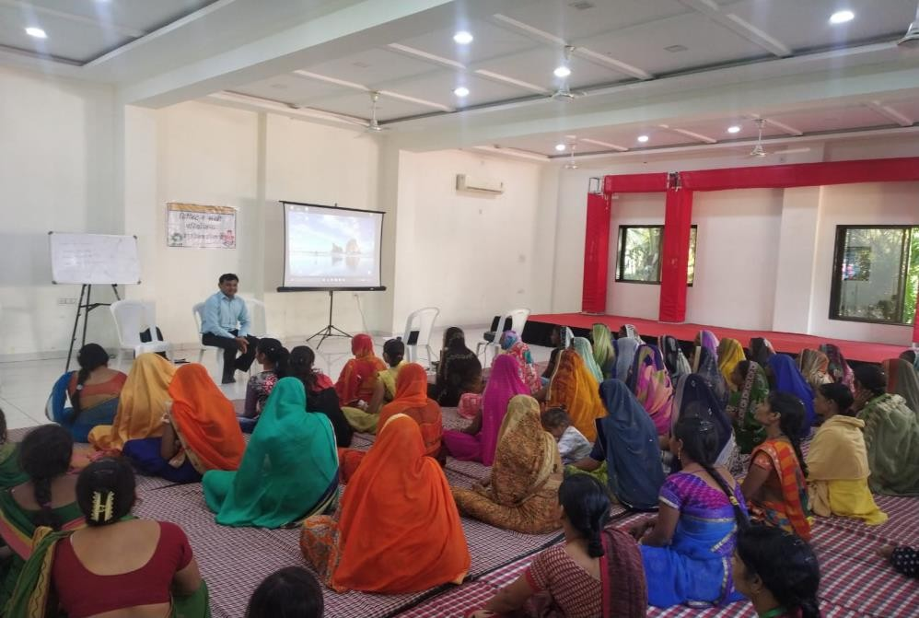
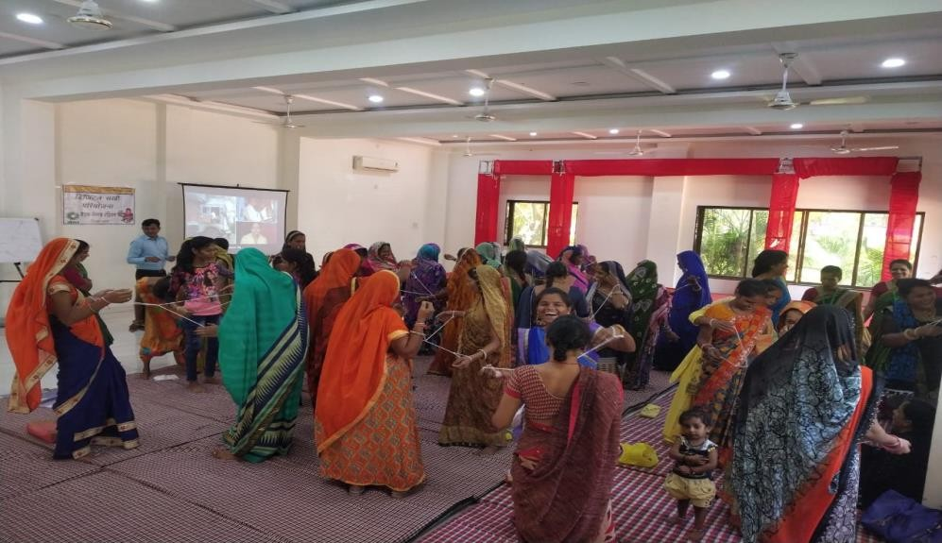

WE EDP Training Dhar & barwani

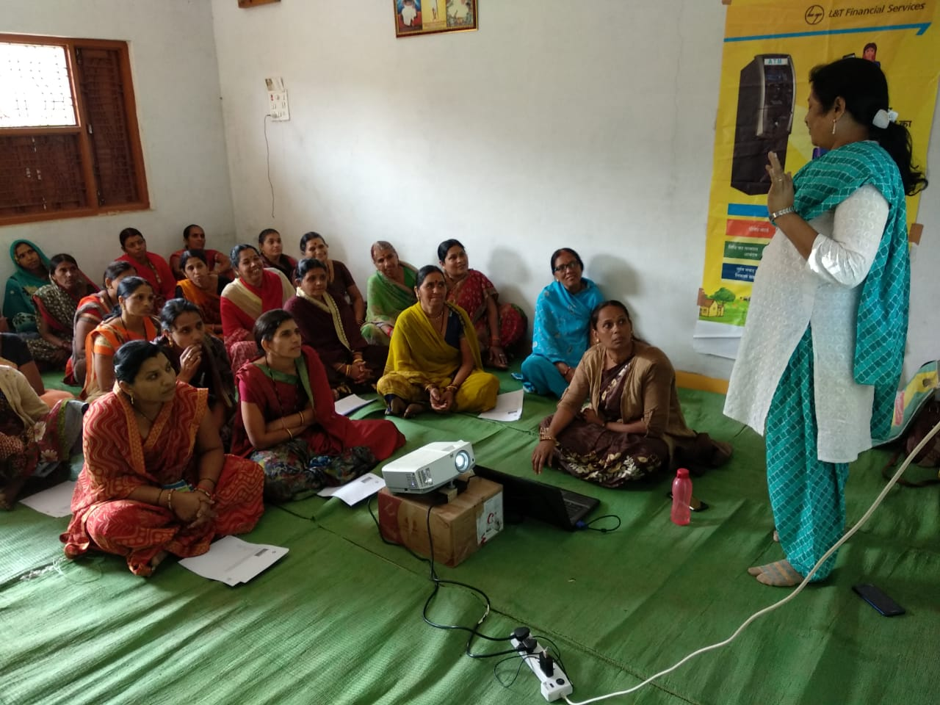

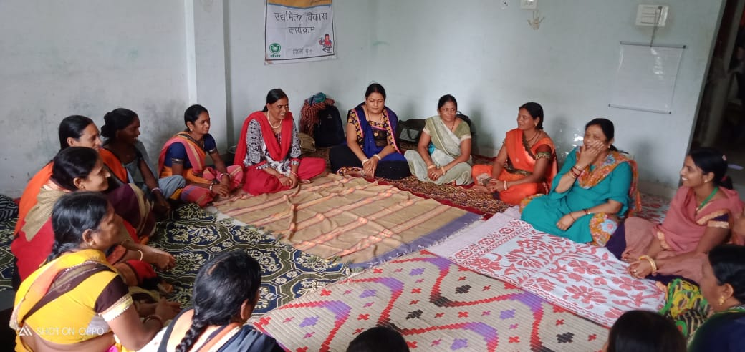

WE Up-skill trainings Dhar & Barwani

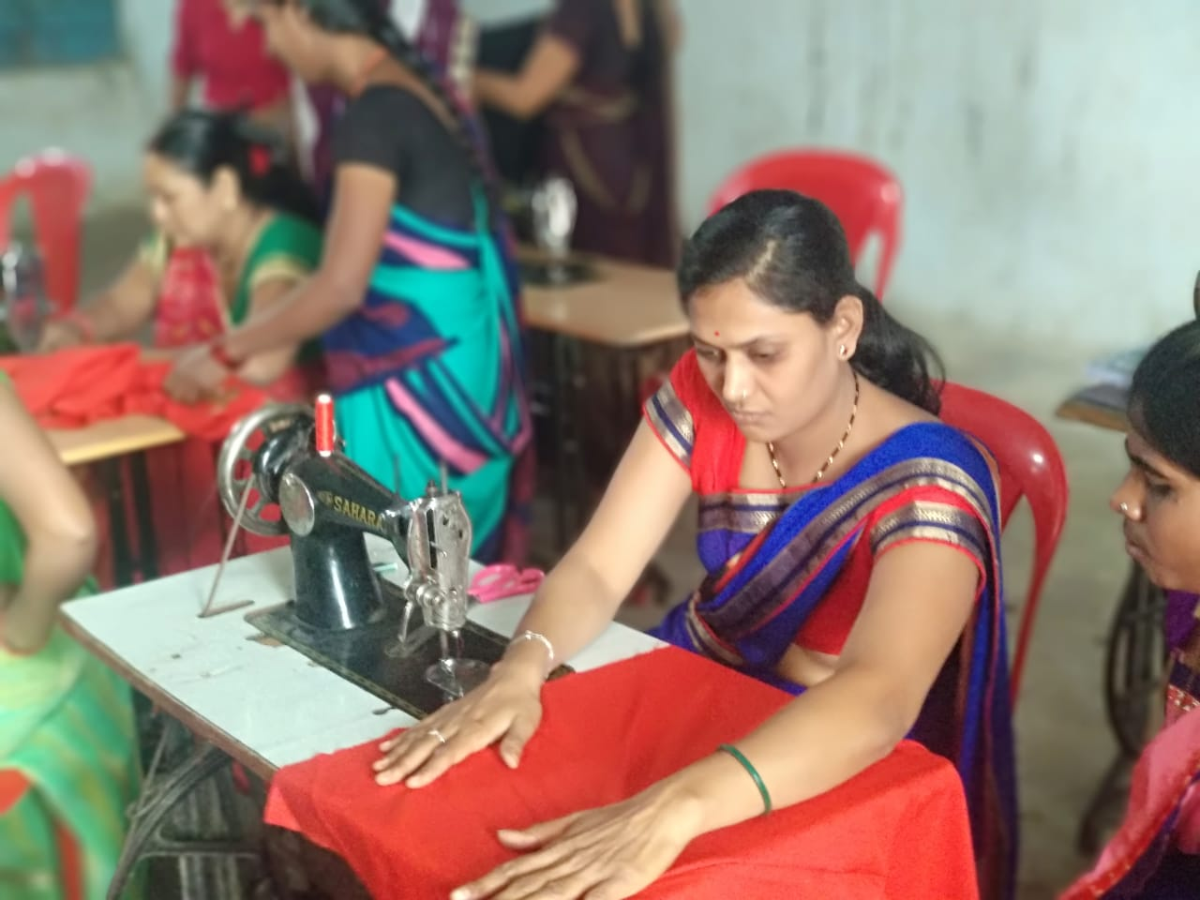

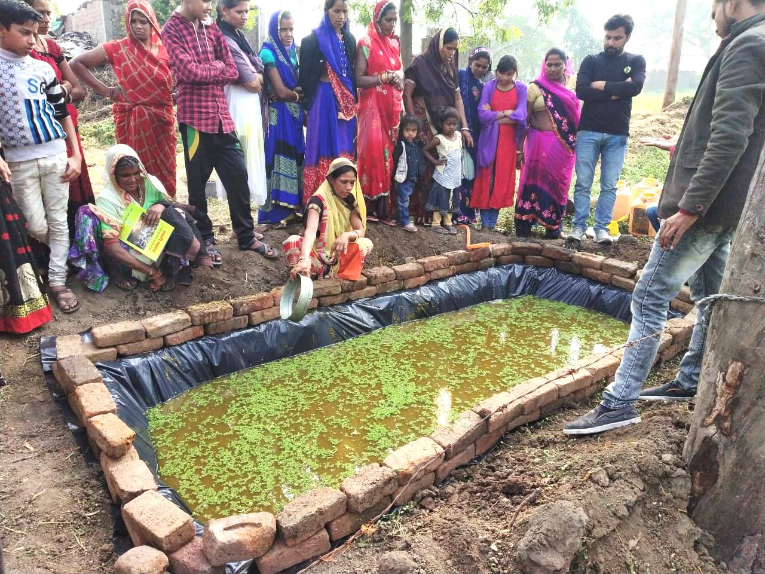

Digi-dhan Camps

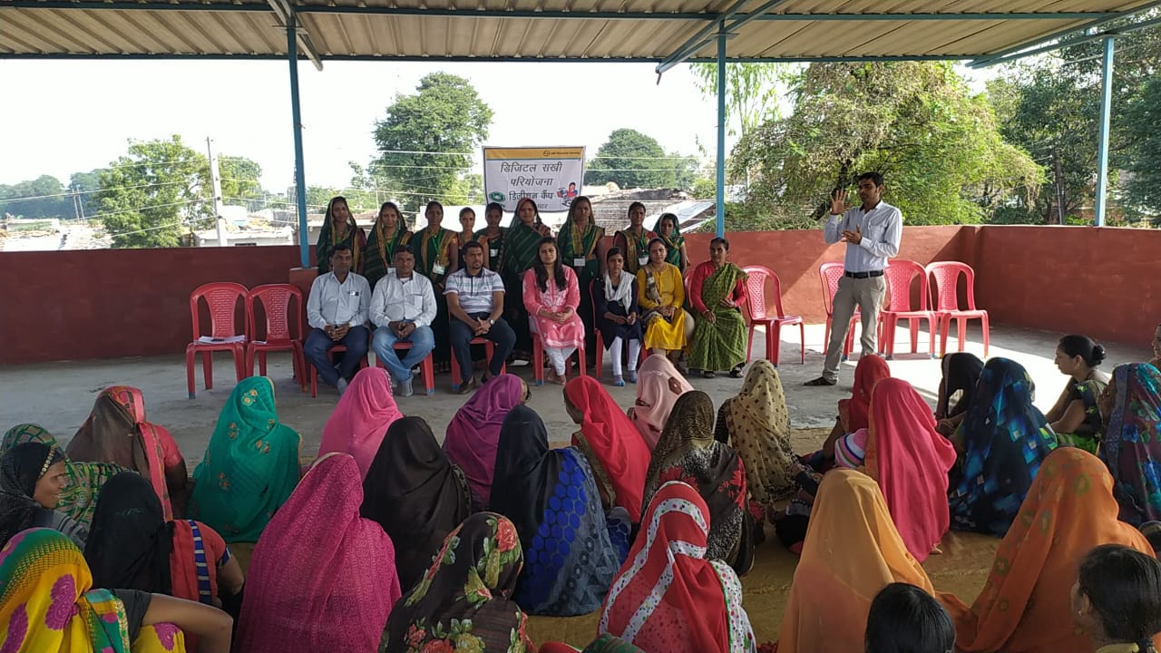

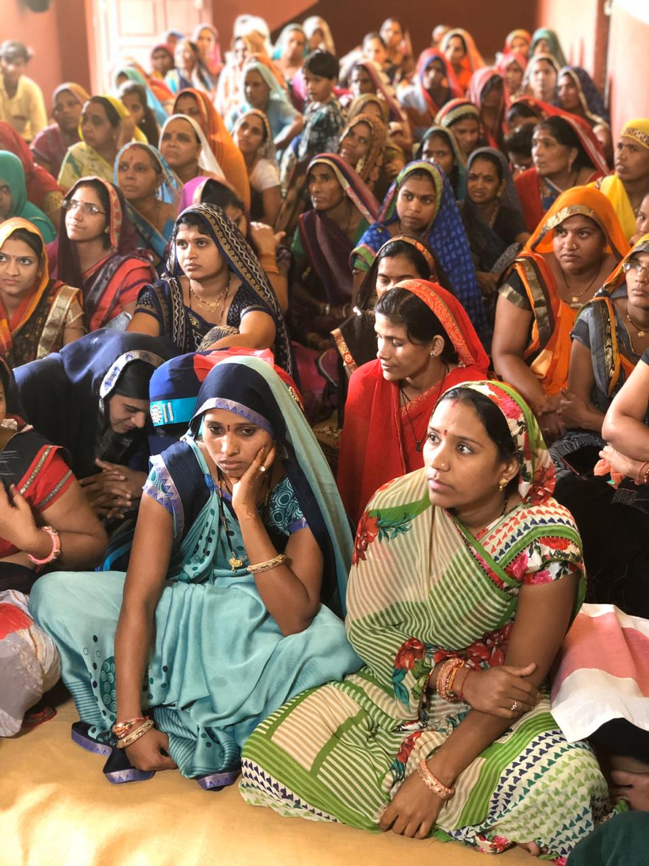
Digital Sakhi Quarterly meeting

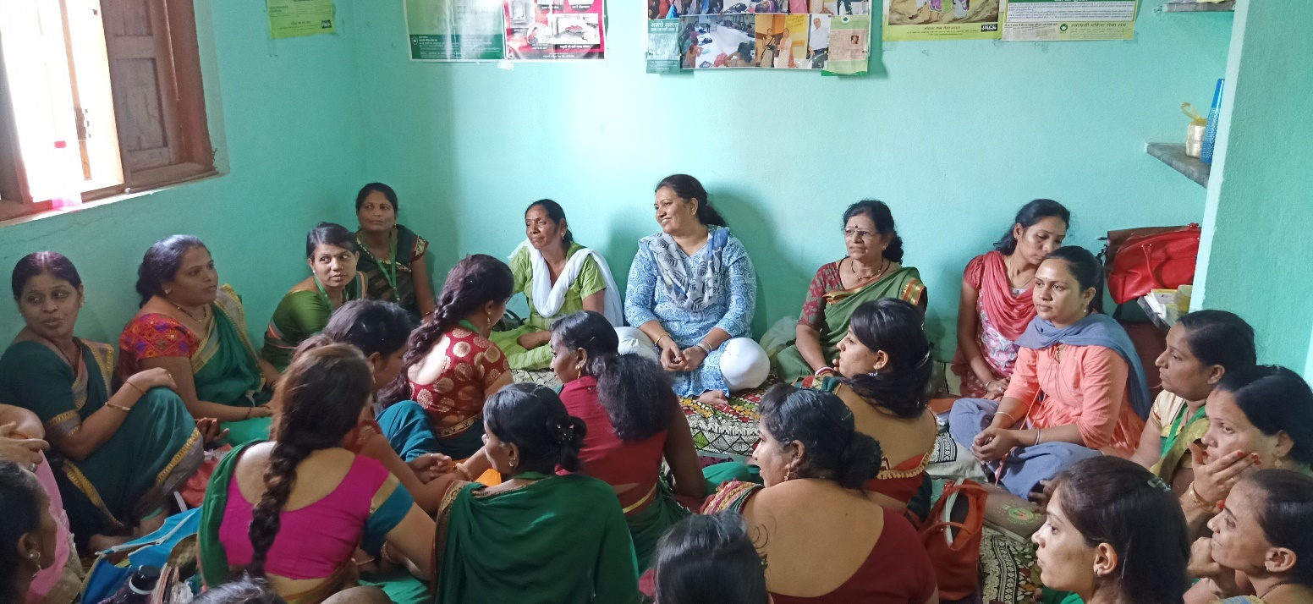

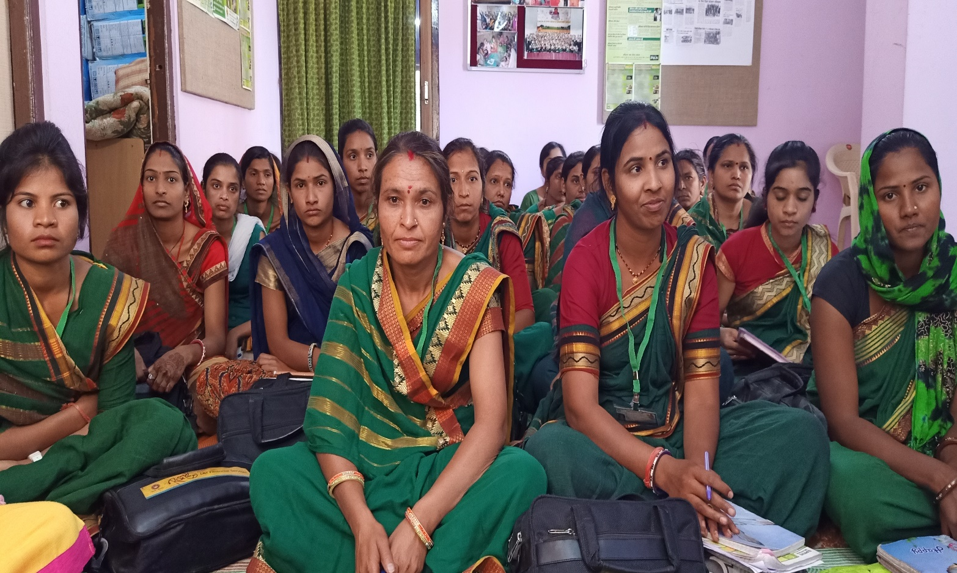

FGD with WE

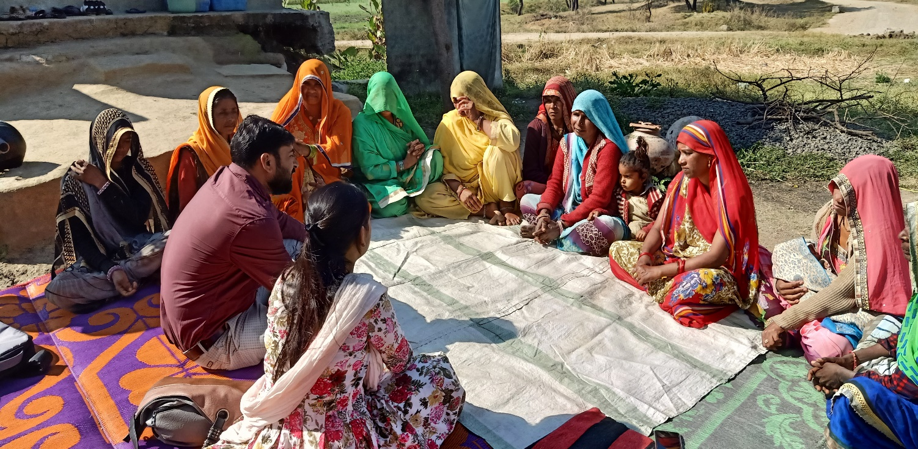

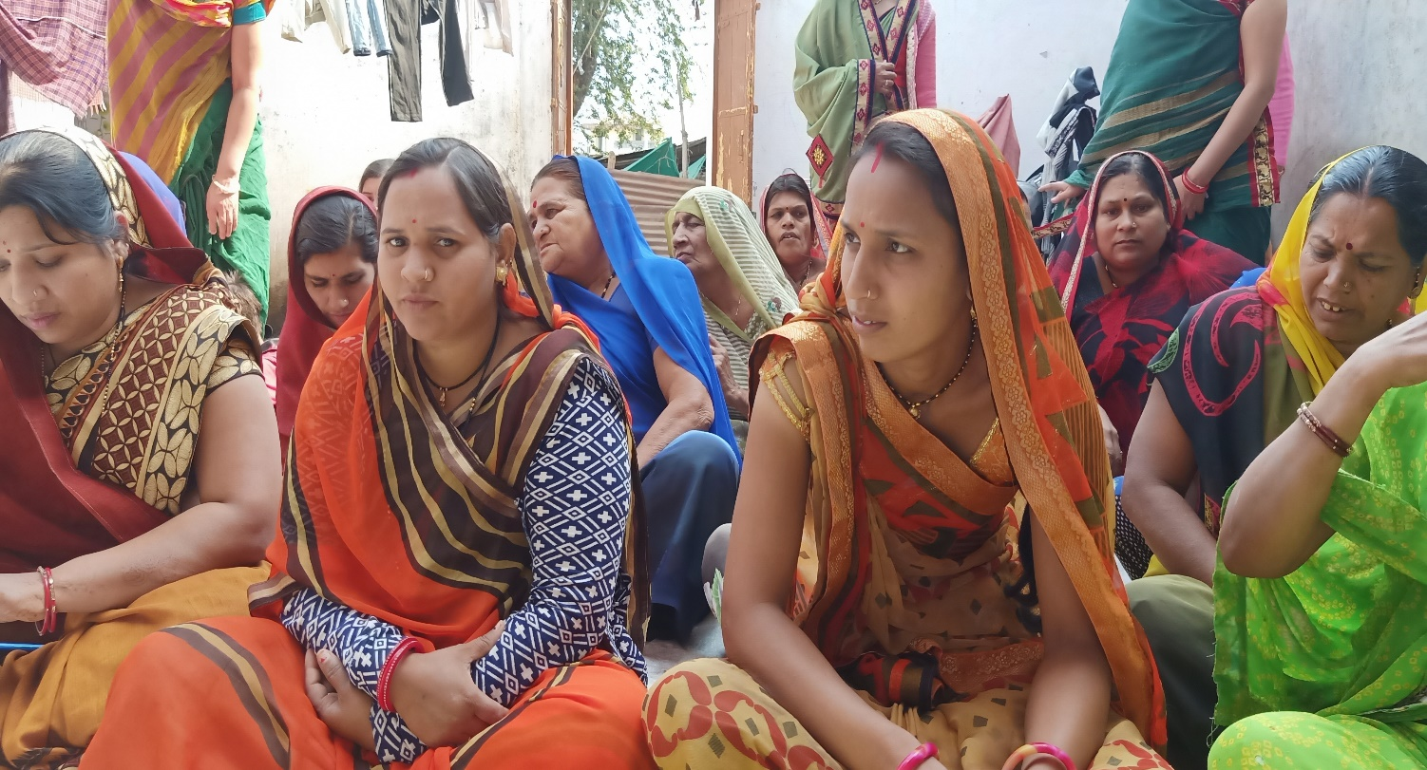

LTFS visit

