Mahila Shram Sewa Nyas Corona relief work report

Organization Interventions:

- Food support Activities: Community members who are not able to access any schemes of government and not getting support from any other relief providers. Organization is identifying handicapped, vendors, elderly, farm laborers, etc. and providing 1 month food basket. Total 3042 families have been benefited.

- Negotiation providing food grains through PDS:
To ensure enough food to the poor during the lockdown, the government started distributing free 5 kg of rice or wheat per person per household to eligible card holders and 5 KG per family grains to those who are not registered under PDS and not getting support from other sources under the Pradhan Mantri Garib Kalyan Yojana (PMGKY).
After the announcement of labor force is visiting for getting the grains to PDS shops but ground realities were totally different. Labor weren’t getting grains from PDS, many shop owners did not receive allotments and they were not providing the grains to vulnerable community members.
Organization did negotiation and coordinated with Block level, District level and State level authorities of MPSCSCL and Food department for providing grains to labors as per announcement of PMGKY.
After continues follow-up community received grains as per the norms through PDS.

- Support through linking with Pradhan Mantri Garib Kalyan Yojana (PMGKY): Organization is linking poor labor women and there family with PM Grib Kalyan Scheme for providing more and more benefits to community with help and coordination of Information Centers and village community members.

- Awareness on Covid-19:
- Door to Door Visit: Community is being aware by Organization with the help of door to door visits where is green zone and in hot spot areas team is informing with the help of Calls, What-App and other social networking sites to 16 districts community members.
- IEC material: Organization is designing, developing and printing pamphlets and sharing to community & soft copies of material also being shared by social networking sites on Covid-19. Awareness is being created amongst the community in 16 districts of State.

- Disseminating Voice & text messages on Covid-19: Organization is also disseminating voice and text messages to community members mobile for bringing awareness on the Covid-19, Pradhan Mantri Garib Kalyan Yojana (PMGKY) and MGNREGA.

- Generating livelihood through providing work to labors: Under this Covid-19 situation, when a lockdown threatens the lives & livelihoods of millions of informal workers and subsequent small supply chain workers stopped receiving orders, Organization is ensuring that the small businesses of this uniquely vulnerable group are protected and to do so it is highly important to get the support of the clientele so they can continue to receive small work assignments at their doorstep. Along with livelihood, it’s critical to cover their health in this corona crisis and Organization is making sure that they are given the required health protection.

Our team is coordinating in market and providing mask stitching work to 986 women's labors in Indore, Dhar, Sagar, Ujjain, Khandwa and Barwani district. All labors are earning 250 Rs per days regularly. It will help them to survive in this pathetic situation.

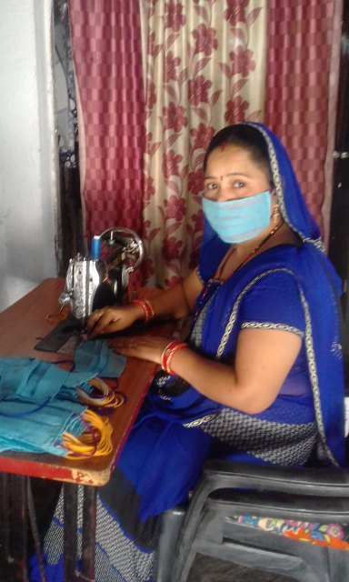

- Online training on Corona awareness through mobile: in Dhar, Barwani, Indore and Ujjain, Organization is orienting 4800 females on Covid-19, its symptoms, preventing, isolation, social distancing, health & hygiene of female, how to care of children & old-age during this situation and combating stigma. Each female is being oriented for 5 days on above mentioned topics and these all sessions are being conducted by 40 Master training with the help of 4 modules.

- Distribution of Sanitary Pads: Organization has taken the initiative of distributing Sanitary Napkins to adolescents girls and women in need and delivery pads to pregnant women, considering it as one of the essentials for women’s menstrual and reproductive health, especially during the crisis when going to shops and hospitals is not safe. Total 2435 free pads have been distributed by Organization to women's.

- Provided work Under NREGA: Our team is doing continues conversation with Jila Panchayat for providing employment to rural labors under the National Rural Employment Guarantee Act. They are making aware to community about NREGA, submitting labors job applications, and providing works. A total 16198 workers received 15 days work under NREGA.

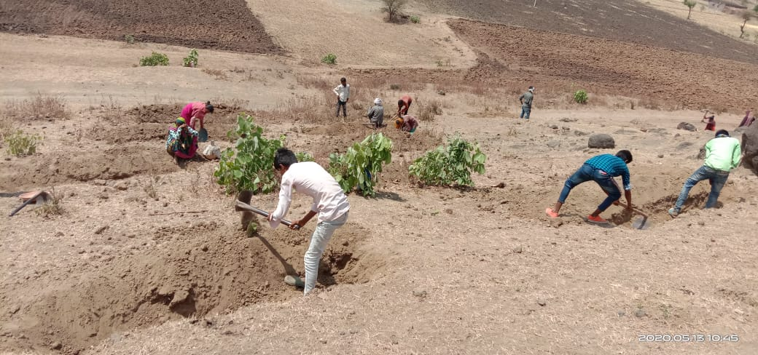
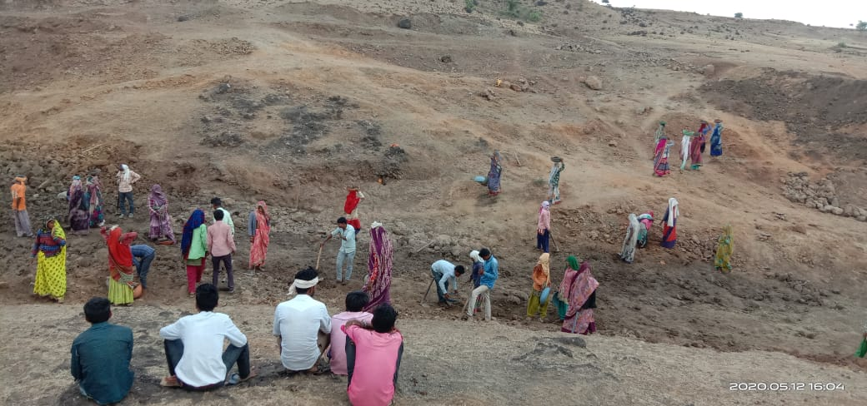

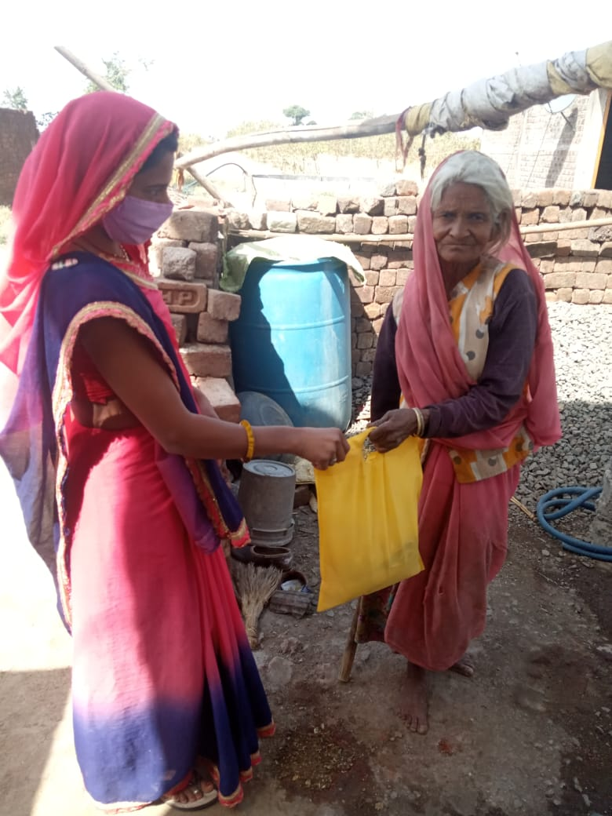
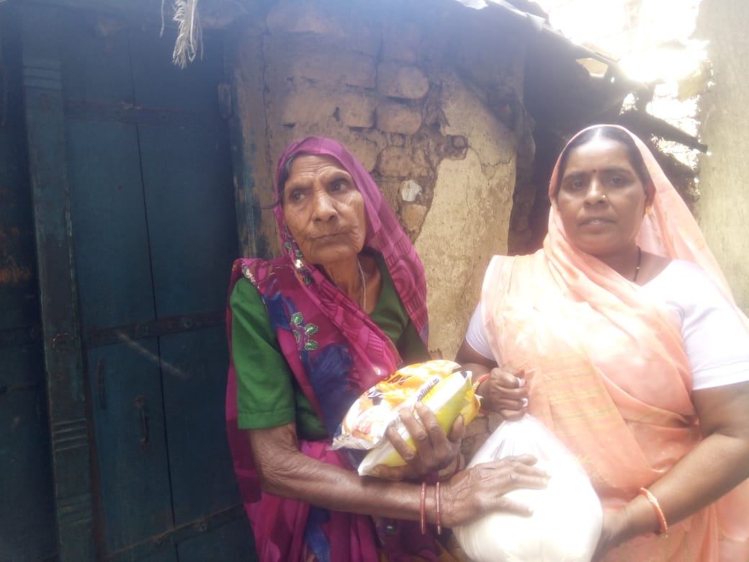

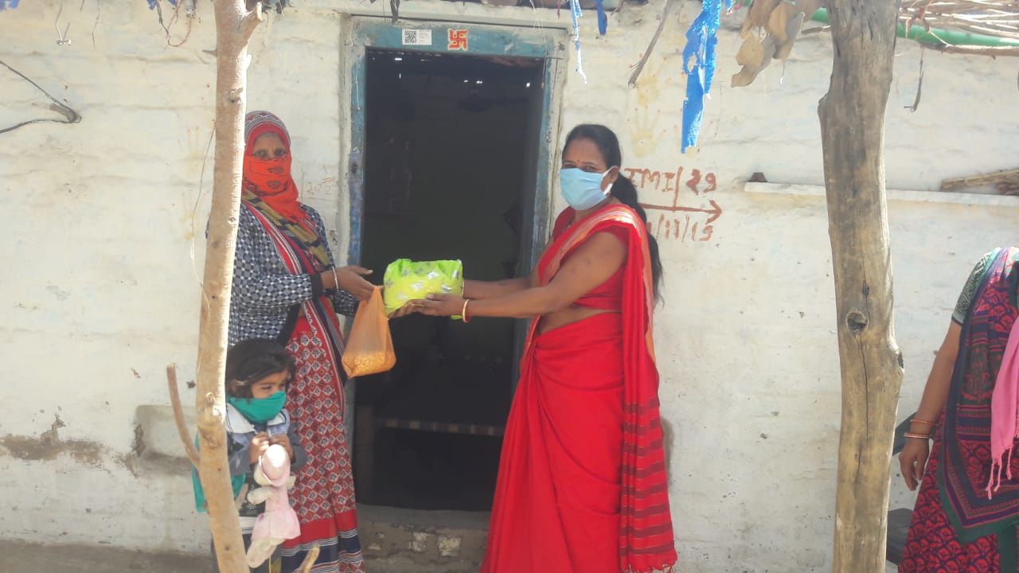
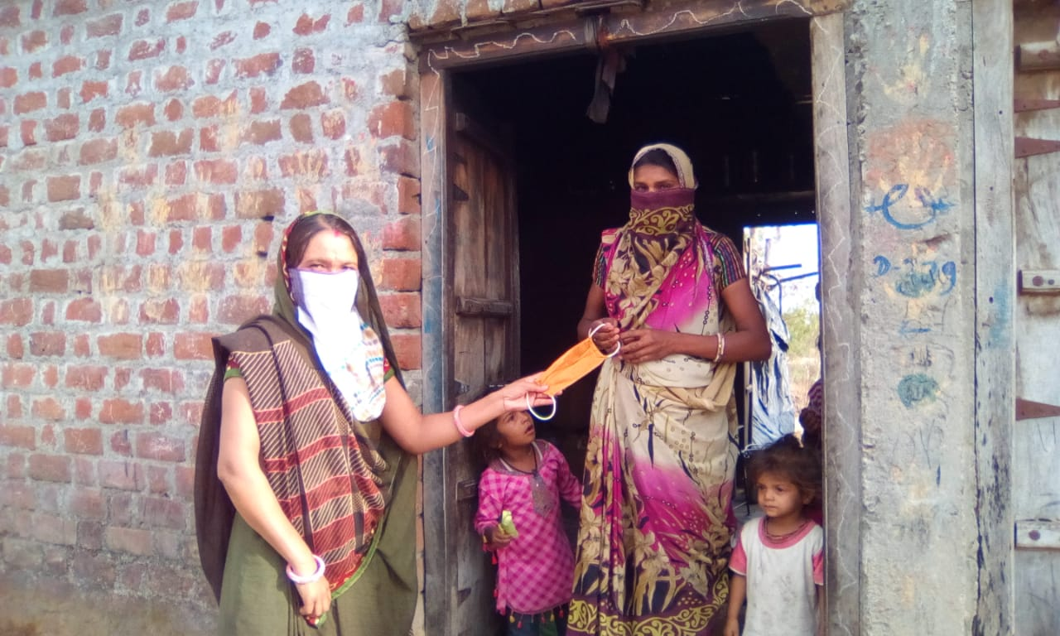
- Provided help to withdraw money of PMGKS: For addressing livelihood issues, direct Cash transfer benefits in accounts are being provided to uniquely vulnerable group members by government through PM Grib Kyan yojana in entire country but the other hand rural poor community members aren’t able to withdraw money of relief funds because they are unable to go to banks and if somehow they make possible their visit to bank, bankers don’t cooperate with them and refuse for transecting money and majority of poor people also not having ATM and some have but ATMs do not have adequate fund due to lock down.
- In this situation community were looking on the sky for help because due to not having cash in hands, how they can safeguard the daily bread-butter and health

- Under these circumstances, Organization team took step, discussed with Banks for sending the KIOSK operators in villages but due to Lock-down, they were not coming in villages, hamlets and remote areas on regular bases. After discussion, Branch Mangers sent KIOSK operators of SBI, NMGB, BOI for transacting the cash of entitlement schemes and provided benefits to 10569 members.
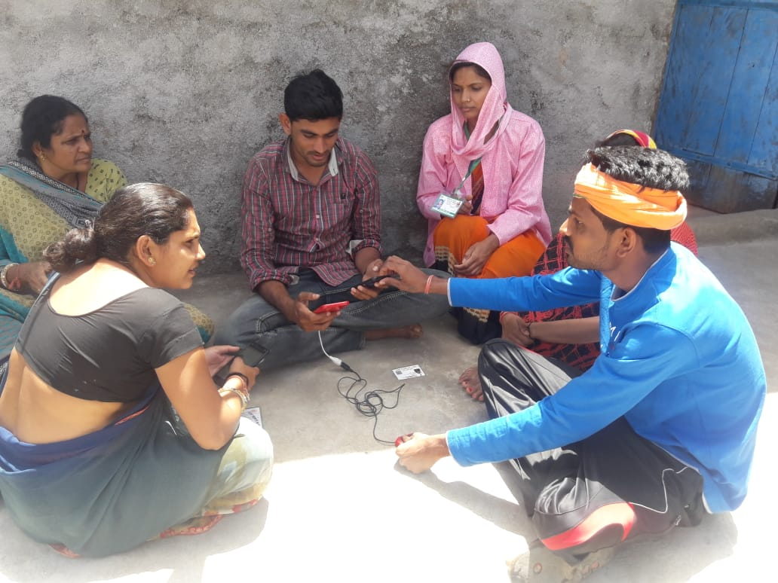

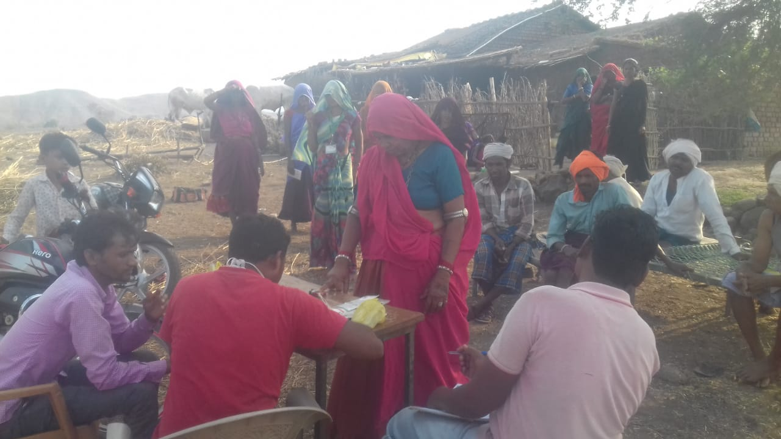

- Distribution of THR and Sanitary pads through WCD Department: In rural areas THR was not being distributed as per the government norms during the lockdown and community was also not ready to go Aganwadi Centre for tacking THR and other facilities due to threat of Corona virus. Our Team members coordinated the Women and Child Development Department and counseled to community about the same and provide take home ration to pregnant and lactating mothers, adolescent girls (sanitary pads) and children. A total 4652 members were benefited through THR and 2671 girls through sanitary pads. More over now the counseling sessions were also started by the WCD department and our team members are also providing counseling to community members on phone and door to door visits.

- Immunization and distribution of Tables through Health Department:
Our team making awareness about covid and counseling to community for tacking Vitamin-C, antibiotic tablets, which are being provided by Ayush Department and also suggesting for vaccination of Children and pregnant mothers. Total 5619 community members got the benefits of tablets and vaccination.

- Distribution of Masks and spray of Sanitizer: for adhering the government instruction and reducing the spread of Covid-19 risk, Our team members did conversation with Gram Panchayts and distributed 50209 Masks to community members and provided sanitizer spray benefits to 89158 families of all implementing Districts.
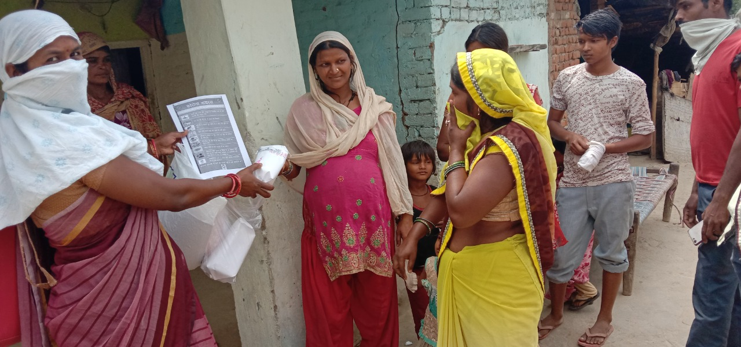

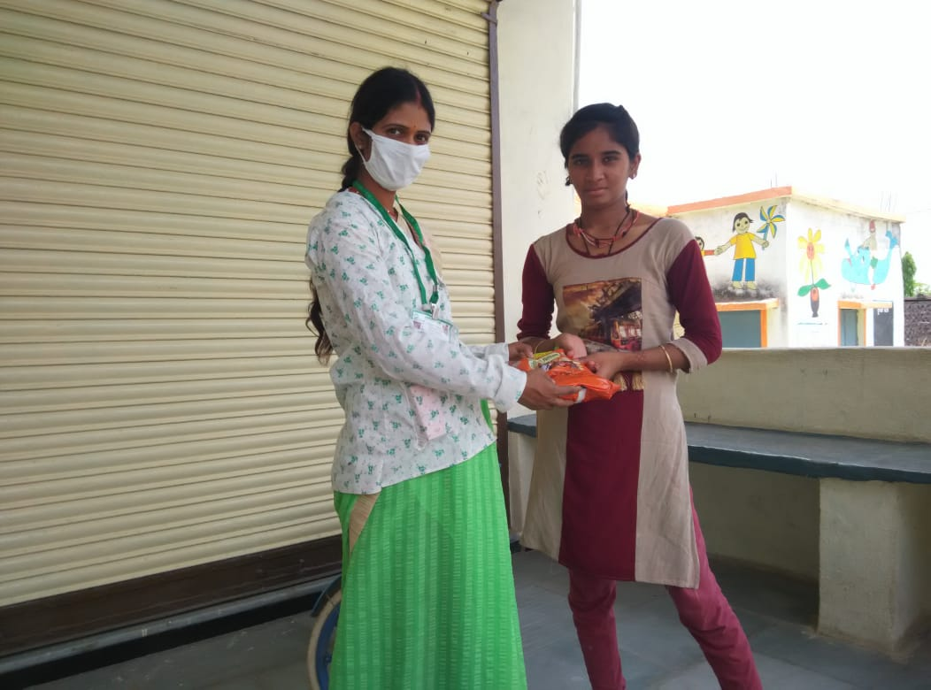

Pics: Distribution of awareness material,THR to adolescent girls and vaccination of mothers and children at AWC

- Provided work to Domestic workers: Organization Many agencies and trust are providing free cooked food to needy and laborers for supporting in this pathetic situation. Organization communicated with these agencies and provided work there to Domestic workers. Total 856 Domestic workers were benefited through cooking work and receiving wages for fulfilling their basic amenities.

Summary of the works which have been doing by Mahila Shram Sewa Nyas
SN | Name of the Scheme | No of Beneficiaries
1 | Raw Food kit distributed By Mahila Shram Sewa Nyas (Families) | 3042
2 | Mask Distribution benefit | 50209
3 | People aware about Covid-19 by VOICE and TEXT messages | 16000
4 | Information and awareness about PM Garib Kalyan Yojana | 82398
5 | Ujjawla Gas Scheme Benefits | 7689
6 | Kisan Samman Yojna Benefits | 31911
7 | Widow Pension Scheme Benefit | 11601
8 | Old-age Pension Benefit Scheme | 9597
9 | Handicap Pension Benefit Scheme | 1289
10 | Jan-Dhan Account Scheme Benefit | 15581
11 | Building_and other construction | 74690
 | Welfare board Scheme Benefit
12 | Food Security Scheme Benefit on card | 21912
13 | Food Security Scheme Benefit without card | 4058
14 | One month Food basket (grains)Distribution through others | 9710
15 | Distribution of Food packets(prepared food) through other | 73198
16 | Distribution of Sanitizer & soap | 5957
17 | Distribution of Sanitary Pads | 2435
18 | Sanitizer spray benefit | 89158
19 | Benefit from National Rural Employment Guarantee scheme | 16198
20 | Employment provided to Stitching workers and Domestic workers | 986
21 | Benefit provided from WCD department | 4652
 | Total | 532271
