Project Report
From July 2019 to May 2020

Details report of women's Empowerment and Rural Development Program

1) Our Goals
1. linking community with welfare board: Organization support to access benefit from unorganized urban welfare board
Serial No. | Works | Benefited Community
1 | Registrations | 4,032
2 | Linking supporting documents in registration process | 6,070
3 | Delivery scheme | 24
4 | Benefits of electricity bill who received extra bills | 431
 | Total | 10,557
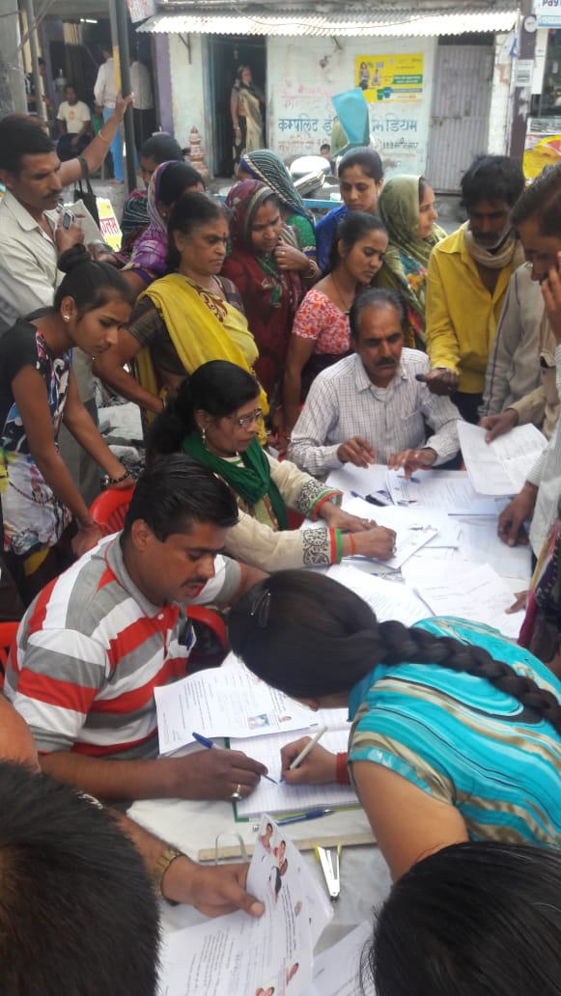

2. To provideaccess to the entitlements under ‘National Food Security Act’, all 24 categories of priority list households in the project locations.
For providing the benefits of eligibility coupons, renewal of food coupons, linking of Aadhar with food coupon, distribution of grains as per government norms, if PoS is not working, through manual process grains distribution and providing bill of grains to consumers, our team and Suchana Kendra Operators communicated through letters with Fair Price Shops, District Food Office, Nodal Officers and JSO & ASO. As a result,Food Security benefits was received by the community.
In Covid-19 crisis, Government of Madhya Pradesh announced 3 months free grains distribution relief packages under Food Security Act, but after announcement Food Department was not distributing grains to community. For addressing the issue Food department at district and block level were negotiated and coordinated by the team and as result, families who do not have food coupons also received rice in urban areas and 5 Kg grains in rural areas also. Moreover food basket and food packet were also distributed to needy community members with the help of Industry owners, other organizations, social workers, lions club,etc.

(A ) Benefits of Food Security to Community
Serial No. | District Name | Food Coupons | Food Coupons linked with Adhaar
1 | Indore | 1,242 | 2,979
2 | Dhar | 570 | 1,040
3 | Dewas | 1,027 | 2,038
4 | Sagar | 853 | 1,327
5 | Ujjain | 821 | 1,644
6 | Chhattarpur | 279 | 978
7 | Khandwa | 927 | 1542
 | Total | 5719 | 12045

(B) Relief work of food security under Covid-19 situation (distribution of ready food packet and food baskets)

Serial No. | Particulars | Benefited beneficiaries
1 | Distributed from Organization | 3,021
2 | Industry owners | 3,827
3 | Lions club | 1,467
4 | Social Workers | 4,024
5 | Other Organizations | 1,810
 | Total | 14,149

( C ) Vigilance Committee meeting
The community members associated with the organisation are members of Vigilance Committee setup under the National Food Security Act.
Our team has regularly met with the Vigilance Committee members and discussedthe problems of food distribution, such as not opening the ration shop on time, not giving bills, non distribution of food grains due to no thumbprints, lost food coupons, etc. To solve these problems, the Vigilance Committee discuss these matters in the official meetings. Along with this, the government also decided 2 days in every month to distribute food grains to those whose thumbprints were not detected. The vigilance Committee plays watchdog during this distribution.
The members of the Vigilance Committee received the information about the meetings in English on mobile. This is problematic for them because they can’t understand English. They raised this issue in the meetings. As a result, now they receive messages in Hindi language. This process also increased the participation of women in meetings.
As earlier organization’s community were made members of Monitoring committees of Food Security Act.

3. To link informal women workers with the livelihood earning opportunities through MNREGA, trimming of Tendu trees in rural areas, and private employers in urban areas.
For enhancing livelihood opportunities in rural and urban areas, villagers were linked with National Rural Employment Guarantee Scheme, and in urban areas, community was linked with private factories, skill development programs and financial institutes.

(A) National Rural Employment Guarantee Act
MSSN linked villagers with MNREGA in 4 working districts. To provide employment under MNREGA, our team which includes organisers, Village Committee members, and Suchana Kendra operators initiated micro-planning process in Gram Panchayat. They submitted a plan in Village Assembly, and pushed Village Head and Village Secretary to approve the plan and budget for MNREGA. Apart form this, the team also handhold villagers in writing job applications, online applications, looking after due wages, stopping the work done by machines, etc. The team also raised burning issues in front of the Panchayat, Janpad Panchayat, and Public Hearing.
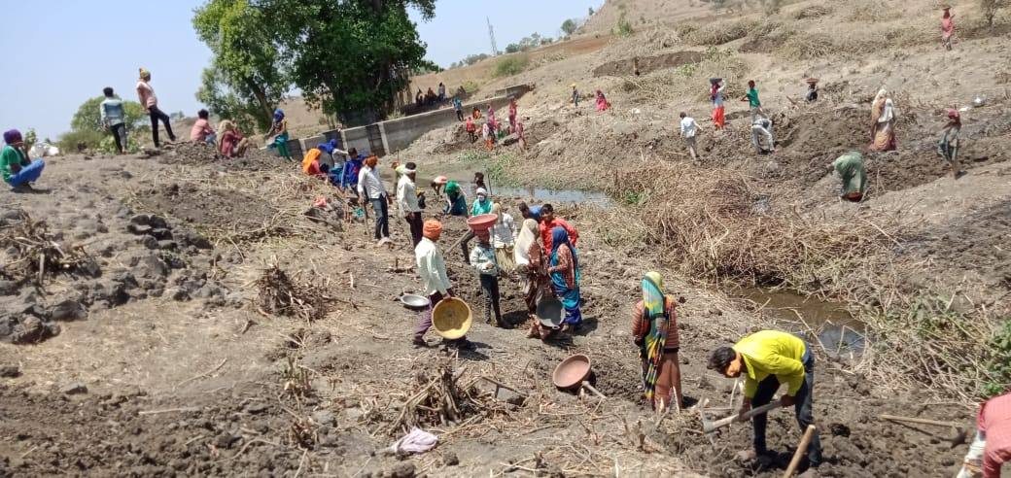

Result of this is in the following table:
Serial No. | District | Working days | Benefited Community | Benefit amount
1 | Indore | 30 | 3347 | 1767216
2 | Dhar | 26 | 3674 | 16,81,224
3 | Dewas | 30 | 4022 | 2,12,36,160
4 | Chhattarpur | 28 | 3157 | 1,55,57,696
 | Total | 114 | 14200 | 7,12,78,240

14,200 families got employment and received benefits on INR 7,12,78,240 in 4 districts.

Activating Village Assembly process
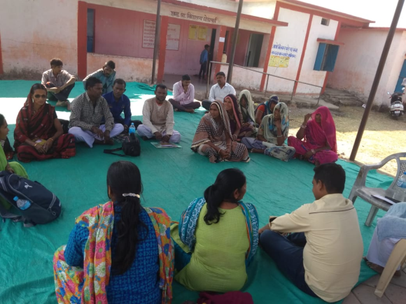
We are regularly pushing Village Assembly process in villages through Village Committee and Information Centres, and also via voice call and text message services. Specially, tried to increase participation of women in Village Assemblies. Result of this process, 1,559 villagers participated in 4 Village Assembly in 29 Gram Panchayats, and discussed village development activities, such as toilets, safe drinking water, primary health centres, working of Aanganawadi, MNREGA, proposals and budget, etc.

© Infrastructure establishment in villages

With the help of MNREGA, our team was able to establish infrastructures in villages.
Sn | Works | No
1 | Village platform | 6
2 | Aganwadi building | 9
3 | Kapil Dhara Kup (Wells) | 18
4 | Pond digging | 6
5 | Repairing of community buidings | 4
6 | Small Pond construction | 2
7 | Animal Sheds | 5
8 | School repairing | 1
 | Total | 61

(D) Livelihood generated in urban areas:
We are working with women labourers who are working in informal sector. Usually they are unskilled, and not able to receive more wages. Also due to GST, home-based workers are unable to find enough raw material. We have regularly negotiated with private employers to find more job opportunities for them.

Following table shows the benefit of these activities:
Sn | Name of the employment | Benefits Community | Amount
1 | Packing work | 227 | 454000
2 | Dry food cutting | 64 | 115200
3 | Sweet making | 39 | 58500
4 | Stitching work | 124 | 434000
5 | Security guard | 12 | 36000
6 | Material packing | 428 | 599200
7 | Bangle making | 326 | 658000
8 | Decorative material making | 172 | 258000
9 | Artificial jewellery making | 82 | 1394000
10 | Domestic work | 42 | 126000
11 | Beauty parlour | 32 | 64000
12 | Chocolate packing | 172 | 309600
13 | Toys packing | 247 | 370500
14 | Envelope making | 920 | 1380000
15 | Paper bag making | 872 | 1209600
 | Total | 3559 | 2354900

(E) Trimming of Tendu trees
The Tendu leaf trimming is necessary before Tendu leaf collection. Tendu leaf trimming is done by the Primary Cooperative Societies from Madhya Pradesh Minor Forest Produce Association.

During this reporting period, due to Covid-19 pandemic Government has imposed lockdown in the entire county. Village Committees have prepared and given the list of people who are willing to do Tendu leaf trimming to District Primary Minor Forest Produce Association. So the villagers gets the work of Tendu leaf trimming and can get wages. This work was monitored by the Village Committee and Information Centre.

Sn | District | Benefited community | Amount
1 | Indore | 1021 | 1225200
2 | Sagar | 627 | 752400
3 | Dhar | 427 | 512400
4 | Dewas | 2172 | 2606400
 | Total | 4247 | 5096400

4247 community got the employment and benefited from INR
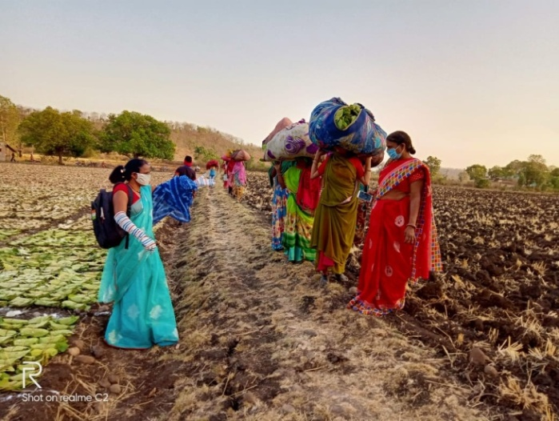
50, 96,400 in 4 districts.

(F) Skill Development Training
Skill development trainings were conducted for unskilled women with support of Jan Shikshan Sansthan, ITI, Municipal Corporation, Collector Department, other private institutions and as result income of the women increased from 10% to 25%.

Sn | Training | Institute | No of trainings | No of Beneficiaries
1 | Stitching Training | Nagar Nigam | 15 | 180
2 | Beauty Parlor | ITI | 20 | 120
3 | Wall Hanging | Private owners | 10 | 60
4 | Decorative Material making | Jan Shikshan Sansthan | 12 | 144
5 | Bangle Making | Nagar Nigam and Collectored | 10 | 80
 | Total |  | 67 | 584

67 community were provide benefits from Skill development programs.
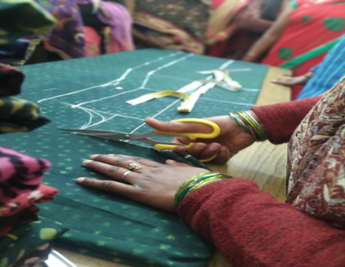
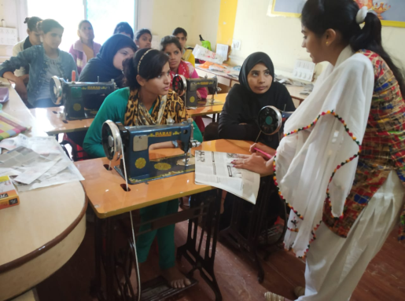

(G) Livelihood generation during lockdown

Due to Covid-19, whole country was in the lockdown, and informal economy workers lose their jobs. We are negotiating with private employers, Municipal Corporation, Ward members, and industrialists, for alternate livelihood. Result of this, garment workers received mask-stitching work, domestic workers were employed in making of food packets, etc.

Sn | Work | Trade | Benefited community
1 | Maks Stitching work | Stitching | 936
2 | Mask Cutting | Stitching | 42
3 | Cooking food | Domestic work | 812
 | Total |  | 1790
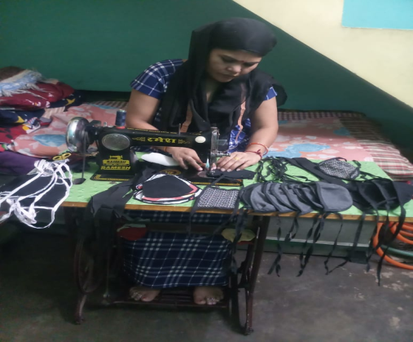
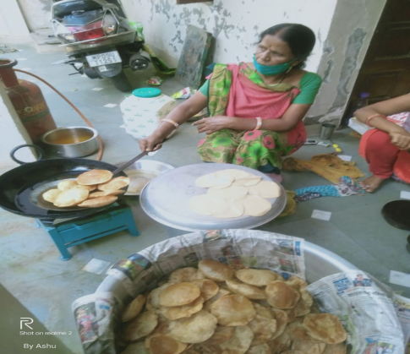

4. Capacity building of community sathis and strengthening of community based centers (CBCs)
To build the capacity of Community Sathis and Information Centre operators, MSSN continuously organised meetings and practical trainings to Village Committee members, and also organised classroom training for Information Centre operators.

(A) Suchana Kendra Meetings
Monthly meetings organised for Information Centre operators, where they discuss issues of community, present their work reports, organisers and district coordinators helped the, to resolve their community issues, and helped them to prepare plans. During the meetings, the team also informed them about any changes in law and policies. During lockdown, their meetings were conducted through conference calls.
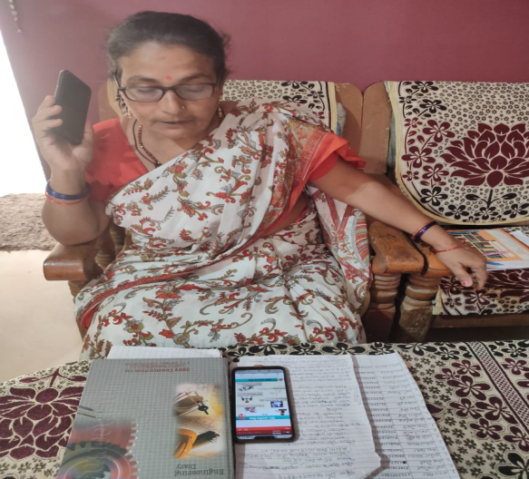

Sn | District | No. of Suchan Kendras | No of meetings
1 | Indore (MHOW) | 16 | 11
2 | Ujjain | 5 | 11
3 | Khandwa | 4 | 11
4 | Sagar | 5 | 11
5 | Dewas | 5 | 11
6 | Chhattarpur | 2 | 11
7 | Dhar | 3 | 11
 | Total | 40 | 77
(B) Training of Information Centre Operators
We have organised 2 training programs for Information centre operators; one for urban, and one for rural. Urban training program organised in Ujjain, and rural training program in Dhar. There they learned about social security schemes, welfare schemes, Aayushman scheme, benefits from Aanganawadi, MNREGA, insurance and health schemes, how to access these schemes, and documents required for them. This is a practical training, and the trainers split them into groups and taught them to fill the forms. After each group work, they give presentations on what they learnt.
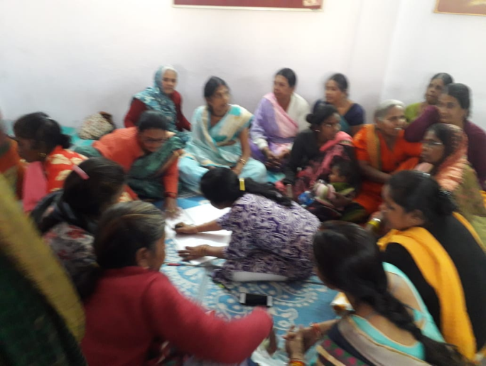

(C) Works of Urban Information Centre
Sn | Schemes | Benefited Community | Amount
1 | Toilet Construction | 33 | 3,96,000
2 | Aadhaar Cards | 76
3 | Correction in Aadhaar cards | 147
4 | Food Coupons | 872
5 | Aadhar linked with Food Coupons | 437
6 | Benefits from Aaganawadi | 43
7 | Basic amenities (Electricity, water & roads) | 168
8 | Family IDs | 201
9 | Sanitation work | 24
10 | Pension benefits | 88 | 88,000
11 | Health Benefits | 69
12 | Aayushman Cards | 674
13 | Housing Scheme | 22 | 55,00,000
14 | Participated in Publuc hearing | 18
15 | Registrations in different welfare boards | 328
16 | Benefits from Social Security | 212
 | Total | 3,412 | 59,84,000

(D) Work of Rural Information Centre
Serial No. | Schemes | Benefited Community | Amount
1 | Aayushman Cards | 547
2 | New Toilet construction/ Completed pending constructions | 167 | 16,02,000
3 | Pension Benefits | 84 | 50,400
4 | Food Coupons | 462
5 | Food coupon linked with Aadhaar | 174
6 | Aadhaar Cards | 102
7 | Correction in Family IDs | 43
8 | Benefits from Aganwadi | 48
9 | Monitoring of Mead-day-meal | 8
10 | Health Benefits | 38
11 | Housing benefits Scheme | 28 | 50,40,000
12 | Benefits from Social Security | 210 | 4,20,000
13 | Facility of Basic amenities | 189
14 | Registration in various Welfare Boards | 487
 | Total | 2,587 | 71,12,400

(E) Village Committee:
At present, corona (Covid 19) has become a big problem, this deadly virus’s infection is spreading everywhere, in such situation Village committees did a lot of work for community such help to community for getting free Ration from Panchayat, prepare list of community members those aren’t having food coupon and submit in Panchayat for providing food grains, Sanitizer spay through Gram Panchayat, Mask Distribution through Gram Panchayat, provide cooked food to migrant labor form Panchayat, check-up of migrant community with support of health department, prepare list of community for providing work under MNREGA, coordination with officials to stopthe usage of Machines in MNREGA, etc.
(F) Works of Village Committees:
Sn | Name of Shcmes | Benefited Community | Amount
1 | Work provide under MGNREGA | 5610 | 7068600
2 | Participated in village micro planning | 15
3 | Participation in Village Assembly | 20
4 | Plantatation work | 1631
5 | Ujjwala Gas benefit | 68
6 | Employment in Tendu leaf Trimming | 1887 | 2264400
7 | Information about Tendu Leaf plucking | 30 Gram Panchayat
8 | Basic Amenities | 310 Panchayats
9 | Benefits from Social Security | 414 | 1035000
10 | Registration in Welfare Boards | 306
11 | Follow-up of Toilet constrution installment from Panchayat | 39 | 234000
12 | New toilet constructions | 132 | 1584000
13 | Kutir Awas (Housing benefits) | 39 | 7020000
14 | Monitoring of Garib Kalyan Scheme | 30 Panchayats
15 | Support to withdraw money from the community at Customer Service Center | 222
16 | Support in Mask distribution | 12 Panchayats
17 | Provided free Ration through Panchayat | 1324
18 | Help for issues Job cards of migrant community | 269
19 | Benefit of cooked food distribution to migrant community for 14 days curentine period | 172
 | Total | 12358 | 19206000
(G) Grading system:
Organization has developed Grading system for Information Centre and Village Committee for evaluating their work on regular basis.
Following are the grades of Information Centres and Village Committees:
Sn | Grades | Village Committee | Suchna Kendra
1 | A | 5 | 13
2 | B | 13 | 17
3 | C | 12 | 10
 | Total | 30 | 40

(H) Practical training of Village committees:
During the reporting period 204 members of 20 Village committees of Dhar, Indore and Dewas districts were trained through practical and classroom trainings on Schemes of Panchayat such as social security, basic infrastructure,MNREGA, FRA, health and education schemes, and how to do work and address problems and issues, information about helpline number, Domestic Violence Act, harassment at work place, etc. Trainers visited Panchayat during training with Village Committee members, and taught them how to negotiate with Sarpanch and Secretary to resolve the issues of villagers.
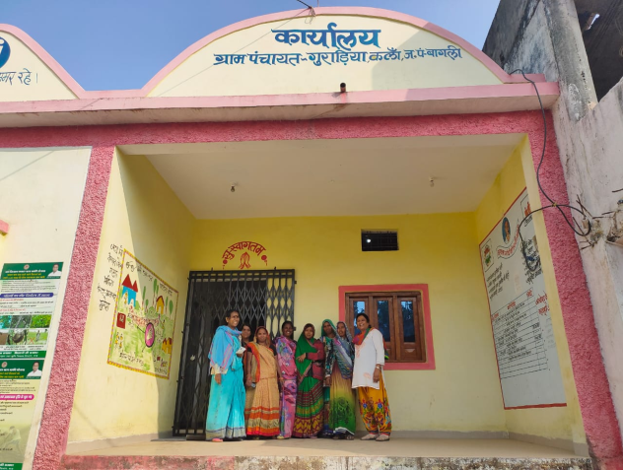
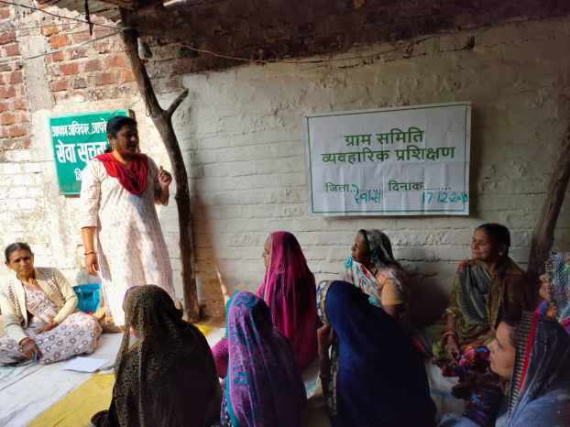

(I) Aagewaan Milan Samaroh:
To build the capacities and sharing their experiences, MSSN organised Aagewaan Milan Samaroh for Village Committee members and Information Centre operators in Dhar, Dewas and Indore. 182 members participated in the Samaroh. We have also invited the Sarpanch, Secretary, Nodal officers, and manager of Tendu Leaf Society. Participants shared their problems in front of them, specially on drinking water, work under MNREGA, Aayushmaan scheme, etc. They also gave a memorandum of demands to the present authorities. Samaroh was ended with sports and cultural program.
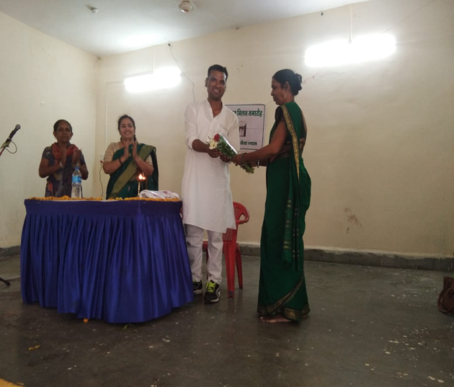
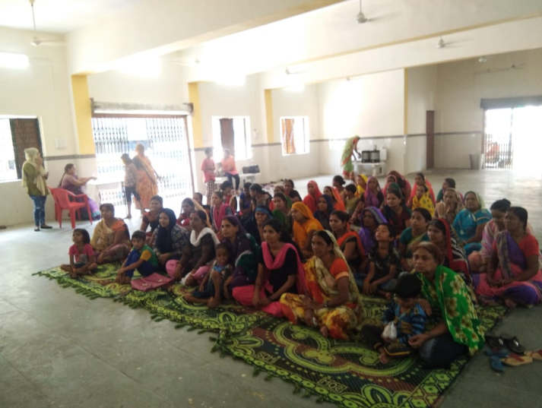

(J) Agriculture Cooperative formation:

We have done all the grassroots level formalities to register agriculture society, negotiated with cooperative registrar. Registration process started from April due to COVID-19, we are unable to proceed further.

(K) Voice call and Text Messages:

Organisation started new communication tools to communicate with community leaders, Village Committee members and Information centre operators. We started voice call and text message services (Suchana Suvidha). 1,000 members received voice call and text message twice in a month on social security schemes, how to access social security schemes, laws and policies, welfare schemes, MNREGA, NFSA, COVID-19 awareness, PM Garib Kalyan Yojana, wages of Tendu Leaf plucking, etc. During COVID-19 pandemic, Suchana Services played and important role in communicating and coordinating with committee leaders.

(L) Training for decision-making committee members

Our targeted community are the part of different decision-making committees of government, such as Shaurya Dal (WCD), Health Committee, Mohalla Committee, Water Committee, Vigilance Committee, etc. To build their capacities as a member of the decision-making committee, the organization organised one-day training program for them in Indore, Ujjain, Khandwa and Sagar. They taught roles and responsibility, and their rights as a member, and how can they push other committee members to take right decisions in favour of poor families. Also, use of CM Helpline to resolve their issues.
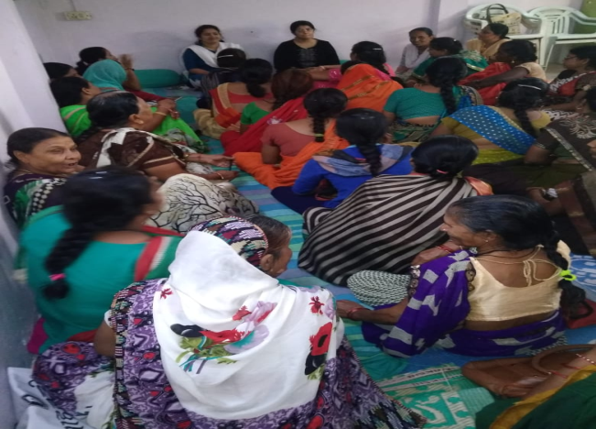
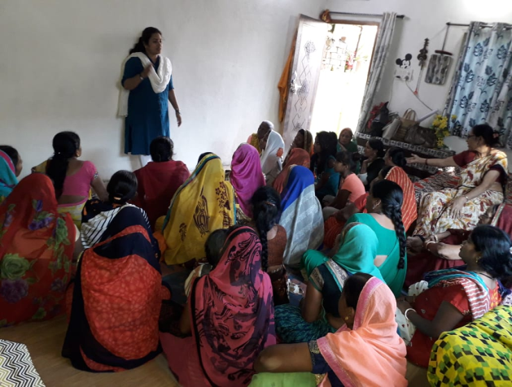

Sn | District | No of trainings | No of Participants
1 | Indore | 2 | 69
2 | Ujjain | 1 | 49
3 | Sagar | 1 | 43
4 | Khandwa | 1 | 41
 | Total | 5 | 202

5. Linking women worker with various other government social security and welfare schemes.
To link women worker with various government social security and welfare schemes, organisation coordinated and negotiated with different Government Departments and Ministries, such as Labour Department, municipal Corporation, Gram Panchayat, Janpad Panchayat, WCD, etc. Our team handholds women workers to fill application forms, collecting relevant documents, to access different schemes. Organization also organised awareness camps to aware and mobilise women workers to access social security schemes. 83 in urban areas, and 54 in rural areas.

(A) Benefits of Social Security from varies Welfare board, Nagar Nigam and Gram Panchayats:
Sn | Name of the Welfare Board | New Registrations | Renewal of registration | Benefits from Schemes | Amount
1 | Bidi Welfare Board | 2044 | 6250 | 1154 | 2308000
2 | Construction Welfare Board | 3024 | 6027 | 2022 | 7077000
3 | Minor forest produce federetion | - | 470 | 72 | 252000
4 | Benefits of Nagar Nigam | - | - | 1622 | 973200
5 | Benefits of Gram Panchayat | - | - | 2026 | 1215600
 | Total | 5068 | 12747 | 6896 | 11825800

(B)Basic amenities:
Our community reside in remote areas of villages and slum of urban. in their areas basic amenties aren’t available such dirty water, no electricity, raw roads, dirt, sludge, no drainage, garbage carts do not come on time, drinking water is not available in summer season , rain water enter in homes, etc. Therefore, through the various schemes of the government tried to provide basic amenities in the areas.

Sn | Name of the Scheme | Urban | Rural
1 | Housing scheme | 22 | 67
2 | Toilet Constrution | 33 | 399
3 | Hand-pump installation | - | 38
4 | Hand-pump repairing | 4 | 12
5 | Electricity facility | 103 | 179
6 | Drainage line | 43 | 21
7 | Drainage line repairing | 12 | 9
8 | Drainage construction | 7 | -
9 | Drainage cleaning | 24 | 7
10 | Facility of garbage vehicle | 18 | 9
11 | Garbage can facility in area | 9 | 16
12 | Cleaning dirty water | 26 | 11
13 | Spray of DDT | 54 | 21
14 | Free water tankers facilities | 16 | 17
 | Total | 371 | 806

(C) Review meeting:

Three training and planning meeting was organised at Indore. Organisers from 7 districts participated in planning meetings to present their annual work plan, quarterly work plan, and present their reports. Program Coordinator and Finance Coordinator also resolved their problems.

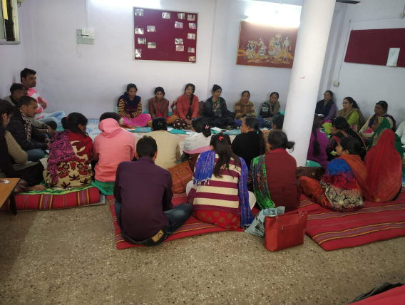
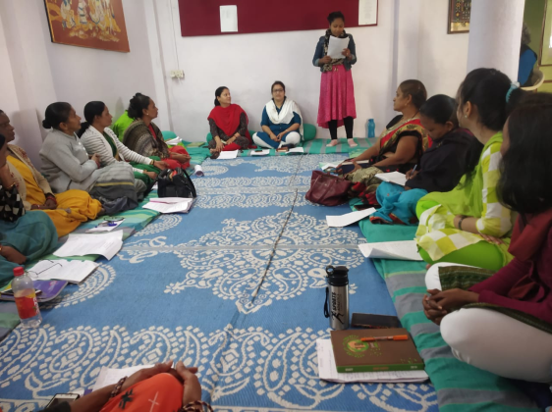

6. To focus more on rural areas, 5 gram panchayats which have been added last year for this purpose and follow ups in 5 old project locations.
In this reporting period in five Panchayats, continuous efforts and follow-up were made by the organisers and Village Committee members for approving the resolution which were made during Village Assembly, and as result, following works completed in 5 Panchayats.

Sn | Works | Numbers | Amount
1 | Family IDs | 14 | -
2 | Housing Scheme | 4 | 72,000
3 | Food Coupon | 92 | -
4 | Pension facility | 41 | 24,600
5 | Due Wages distribution of Palnation work | 160 | -
6 | Incomplete paltform construction | 2 | -
7 | Village development work (Drainage construction, road repairing, boundary wall of crematorium,  Mud cleaning, Hand-pump repairing | 31 | -
8 | Rest instalment of toilates | 9 | 1,08,000
 | Total | 353 | 2,04,600

