Case Study 1

Aarti Alawe – A journey from victimhood to empowerment.
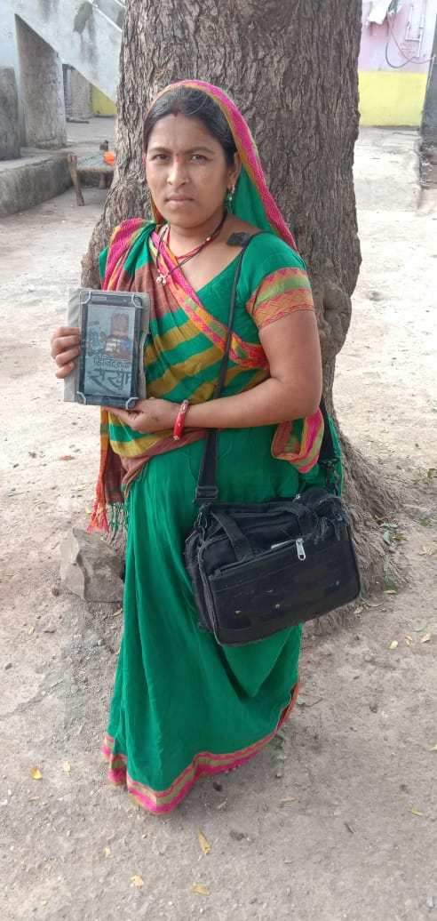
Once a victim of domestic violence, today, Aarti Alawe , walks tall and takes pleasure in the fact that her husband respects her. All, thanks to organization, which freed her from the confines of her home and an overbearing husband who would beat her up every time he got drunk. Which was almost every other day.
So, what brought about this change of heart in Aarti’s husband? Digital Sakhi! As a Digital Sakhi, Aarti needed to undertake field visits and impart training in financial and digital literacy to villagers. This got her husband thinking. What if people think that as quarrels with him are an everyday feature in their household, she is incapable of teaching anything? That, if she cannot command respect and dignity at home, how will she do it with the community at large. These thoughts impelled Aarti’s husband to quit drinking. And, what’s more, this act had a ripple effect. Aarti’s mother-in-law and sister-in-law took to helping her out with household chores and taking care of her children.
Along with family support, Digital Sakhi also brought Aarti financial independence. She could now use what she earned through the programme her way, in the things that were close to her heart, in things that really mattered. Aarti’s brother studying in Class 7 had been stopped from appearing for the year-end examination as he was unable to pay the school fees. Aarti stepped in and gave him Rs. 500 so that he could pay the fees and take his exams. Also, she gifted her husband Rs. 5000 to buy a mobile phone.
Inspired by the programme, Aarti went to the bank and opened an account after completing the KYC formalities. She also went to the Panchayat, met the Sarpanch and enrolled for the Food Coupon scheme.
Aarti, the woman who once led a cloistered life, today strides out to help others and herself as well. She says, Digital Sakhi has made her fearless and brought dignity and respect to her life.

Case Study 2.
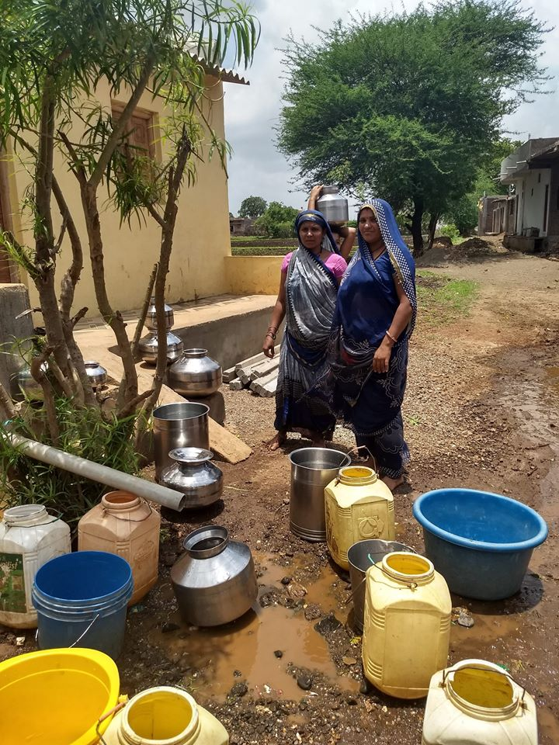
Band of Sisters Get Water to their Village
The group of our organizer not only teach villagers how to make digital transactions but also ensure that they get basic amenities like, water.
Niwali village does not have water pipelines and women had to walk long distances to fetch water for their households. Thanks to the initiative taken by our organizer, the village would soon get piped water.
This did not happen overnight. The our organizer, sharing a close bond of sisterhood, took it upon themselves to rectify the situation. They started off by creating awareness about the issue amongst the women in the village, urging them to attend the Gram Panchayat and petitioning the Sarpanch, the village head. When that didn’t work they registered a complaint on the CM’s Helpline.
Soon enough, they got a response. Officials visited Niwali to verify. The Sarpanch organised for water tankers to reach homes every two days. He also requested for the complaint to be withdrawn! But the our organizer refused saying it would be withdrawn only after each home in the village has a tap and water connection. So, pipelines are being laid and the water woes of Niwali would soon be a thing of the past!

Case Study.3

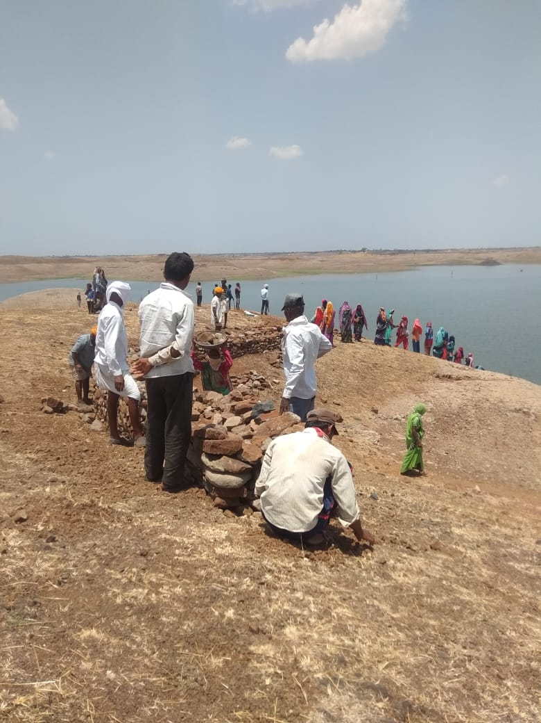
As Government of India has announced that work will be provided to labors in Rural area under the Nation Rural Employment Guarantee Act in catastrophic situation but the ground realities are different. Our one working village Rajod. Labors were ready to work but Gram Panchayat was not providing work to labors under NREGA. Labors were facing problems due to not having any work.
Our organizer Ms Geeta Dhakad gathered labor at Panchayat and demanded for work under NREGA but villagers weren’t getting work than she took step and discussed with Village Sarpanch than village Sarpanch started work under NREGA and providing 15 days’ work to 50 labors in village.
Labors said that because of your organization, and organizer helped us and provided work. Now from this wages we will be able to fulfill our basic amenities.
Total 50 labor will receive 1,42,500 Rs wages from this work.

